Energy Source Sheet

In this group you will learn about different types of energy so that you can decide how your building
structure will be heated and how it will get electricity.

Step 1: Currently, most buildings get their heat, and possibly the energy for their ovens, from natural gas - a fossil fuel. To meet the net-zero greenhouse gas emissions by 2050, you will have to select a different fuel source for your building.
- Read the introduction to alternative fuels below. For this project, we are assuming that technology is in place so that the fuel options listed below that power vehicles can also be used to heat building structures. You can assume that the building will have the same emissions as the car.
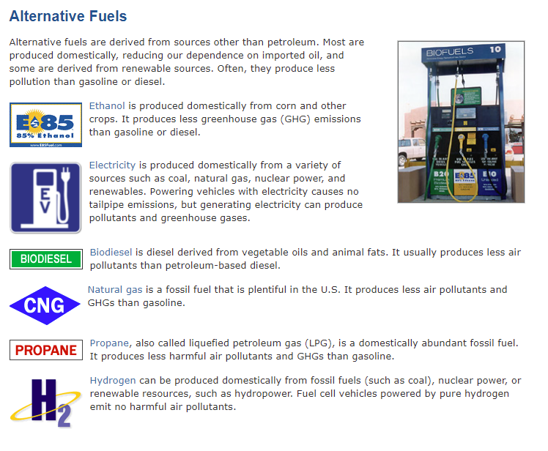
Figure and information from https://www.fueleconomy.gov/feg/current.shtml

- Each member of the expert group should choose one of the energy sources to research using the links provided below. Complete appropriate worksheet for the energy source you choose.

- Ethanol: https://afdc.energy.gov/vehicles/flexible_fuel_emissions.html
- Electric: https://afdc.energy.gov/vehicles/electric_emissions.html
- Biodiesel: https://afdc.energy.gov/fuels/biodiesel_benefits.html
- Natural gas: https://afdc.energy.gov/vehicles/natural_gas_emissions.html
- Propane: https://afdc.energy.gov/vehicles/propane_emissions.html
- Hydrogen: https://afdc.energy.gov/fuels/hydrogen_benefits.html

Step 2: Currently, most buildings get their electricity from fossil fuels. In order to meet Biden’s goal of 100% carbon pollution-free electricity by 2035, you will have to select a carbon-free way for your structure to get its electricity.
- Review the information presented here: https://www.eia.gov/energyexplained/renewable-sources/ to define renewable energy and see the different types of renewable energy.

- Each individual should choose one type of renewable energy to focus on. Use the links below to learn about the renewable energy that you chose and complete the Pros and Cons Worksheet for your energy source.

Pros and Cons research documents on renewable energy
- Solar energy: https://www.solarreviews.com/blog/pros-and-cons-of-solar-energy
- Wind energy: https://www.windustry.org/pros_cons_wind_energy
- Geothermal: https://www.solarreviews.com/blog/geothermal-energy-pros-and-cons#what-is-it
- Hydropower: https://www.energysage.com/about-clean-energy/hydropower/pros-cons-hydropower/
- Nuclear energy: https://www.solarreviews.com/blog/nuclear-energy-pros-and-cons
- Biomass energy: https://www.solarreviews.com/blog/biomass-energy-pros-and-cons

- When everyone is finished learning about their renewable energy source share the information with your group. There is a space in the worksheet for you to take notes.

Additional energy resources:
https://www.youtube.com/watch?v=KEeH4EniM3E
https://www.youtube.com/watch?v=uihEg92u9Vg

