Lab Activity Handout Answers

Problem: Which nanoparticle will bleach (or “photo-sanitize”) water the fastest after UV light exposure: titanium dioxide, zinc oxide, or magnesium oxide?
Hypothesis: I predict that the titanium dioxide nanoparticle will bleach the fastest
because the chemical properties of titanium dioxide make it the most effective.
Materials:
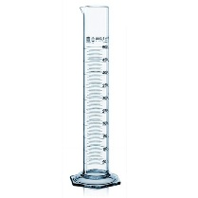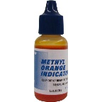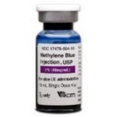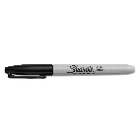
SAFETY
Equipment

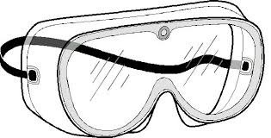
___goggles__
lab coat/apron

graduated cylinder methyl orange methylene blue micro pipette marker
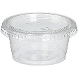 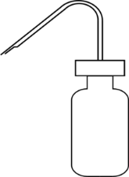 ZnO zinc oxide_
stopwatch plastic cups (2-oz) distilled water MgO magnesium oxide
TiO₂ titanium dioxide
Procedure:
- Collect all _materials_; designate responsibilities to each lab group member, if needed.
- Obtain _8__ plastic cups with lids and pour _20__ ml of distilled water into each cup.
- Pour ___3__ml of methyl __orange___ into the 4 cups with water.
- Pour ___3__ml of methylene ___blue________ into the other 4 cups with water.
- Label the four methyl orange cups as ___ZnO_______, _______MgO__, _____TiO₂________, & “CONTROL.”
- Label the four methylene blue cups as ______ZnO________, __MgO______, __TiO₂________, & “CONTROL.”
- Use a ___pipette______ to place ___3____ drops of each sample oxide as labeled on your cups & be sure to _____stir/mix______ your solutions well.
- Take a ___picture___ of your methyl orange and methylene blue labeled cups with your phone (before light exposure) and be ready to take your cups outside for UV light exposure.
- Using a stopwatch, record the time in ___seconds_ it takes for each sample to bleach (do not run longer than 10 min). Take another picture of the cups (after light exposure).

Data Table:
COMPLETE BLEACHING AFTER UV EXPOSURE in seconds
Sample solutions | CONTROL | Titanium Dioxide | Magnesium Oxide | Zinc Oxide
Methylene blue | No bleaching
Methyl orange | No bleaching

Illustration: (students color in their results using their picture before & after light exposure.)
Samples before UV light exposure
Methylene Blue Samples Methyl Orange Samples

ZnO MgO TiO₂ ZnO MgO TiO₂

Samples after UV light exposure
Methylene Blue Samples Methyl Orange Samples
c
c
c
c
c
c

ZnO MgO TiO₂ ZnO MgO TiO₂

Conclusion: I accept my hypothesis because titanium dioxide was the nanoparticle that bleached the dye the fastest. This is due to its photocatalytic properties that we discussed in class.

