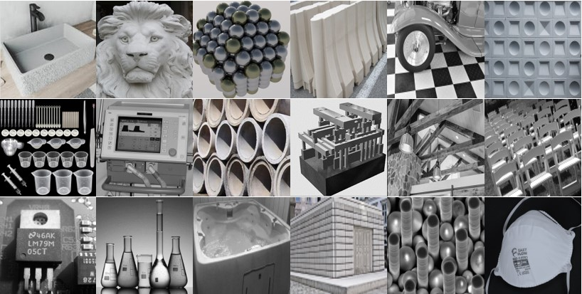
Design Engineering Student Worksheet Answers

Sink –rectangle; waterproofed cement; circular metal drain; mold had inset or walled mold to prevent filling | Lion head – part of 3D architecture; cement; one-pieced mold with varied shapes and depths | Nanotechnology beads -spheres 3D; metal; hollow and solid spheres possible | Road barriers – cement; mold | Car – varied shapes and materials for parts put together in a high-fidelity prototype on top of squared flooring | Wall – cement; different shapes from different mold and placed together; no materials in center due to mold
Scientific and Biomedical containers for delivering liquids – plastic molds; precision of molds important | Respiratory Ventilation Process – numerous parts on exterior and interior of varied shapes and materials; high-fidelity prototype | Drain pipe – cement; open cylinders; varied diameters/thickness and ends | Nanotechnology – computer part; varied materials made from separate molds and assembled into prototype | Ceiling trussle – architectural wood with metal corners in triangle; supports weight of ceiling distributed and also decorative | Chair – resin/plastic; different parts assembled together
Nanotechnology – microchip; varied conductive and non-conductive materials assembled together | Scientific glassware – precision mold; varied sizes relate to volume capacities | Hot tub – large plastic mold with cut-ins; final prototype contains numerous plastic parts assembled together on exterior | Mausoleum – constructed of cement rectangles from molds assembled together; interior hollow | Nanotechnology – spheres and discs from different molds attached together; silicon | Face mask – consistency in template and material pores important

