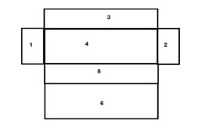
Surface Area Worksheet

If a rectangular box is opened:
1,2 = base or ends
3,5 = sides

4 = bottom or floor
6 = top or ceiling

Shape | Lateral Surface Area (LSA) | Total Surface Area (TSA)
Cuboid | 2height(length + base) | 2(lb + bh + lh)=2Bh + (perimeter)(height)
Cube | 4a² | 6a²
Prism | Base perimeter × Height | LSA + 2 (area of one end)
Cylinder | 2πrh | 2πr(r + h)

- Define the following terms:
  - lateral surface area

  - total surface area

  - two-dimensional (2D)

  - three-dimensional (3D)

- Draw the geometric shapes for the following objects:
- cuboid

- cube

- prism

- cylinder

Show the equation and solving of the following problems:
- The dimensions of a right rectangular prism are 4 inches by 5 inches by 6 inches. What is the surface area, in square inches, of the prism? (Convert to centimeters).

- A cube has a surface area of 54 square meters. What is the volume, in cubic meters, of the cube? (Convert to centimeters).

- A cubic prism has the dimensions of 4 inches by 4 inches and a height of 10 inches. What is the surface area? (Convert to centimeters).

- Find the surface area of a right triangular prism with sides of 3 inches x 4 inches x 5 inches and a height of 12 inches. (Convert to centimeters).

- What is the surface area of a cylinder with a radius of 3 inches and a height of 6 inches? (Convert to centimeters).

