Much More than Pretty Colors Worksheet

Introduction: Food coloring dyes have been used to enhance the color, taste and to improve the overall quality of the food. There are several natural and artificial food dyes. Have you ever thought about what makes a good food color? First, it should be soluble in water and second it should retain the color for a long time. How is that possible? Food dyes are ionic compounds that dissolve in water as both are polar. Food dyes absorb and transmit a certain color by the molecules in the dye with the excitation of electrons.

Engineers use this relationship to identify the various components in food. Today you will be the quality control engineer in a food and beverage factory and will analyze the given Gatorade to measure the amount of food dye by constructing a simple spectrophotometer. In this experiment, you will be assigned a blue Gatorade. You will first prepare a dilute solution of assigned concentration from a stock solution of FD&C blue dye #1. You will then construct a spectrophotometer using popsicle sticks and smartphone color name software. Then you will measure the absorbance of the solution using this spectrophotometer. A Beer’s Law graph of absorbance values vs. concentration will be generated using the class values for different concentrations. You will then use the graph of your data to determine the concentration of the dye in the beverage.

Background: White light is a part of electromagnetic radiation and composed of different colors with different wavelengths.
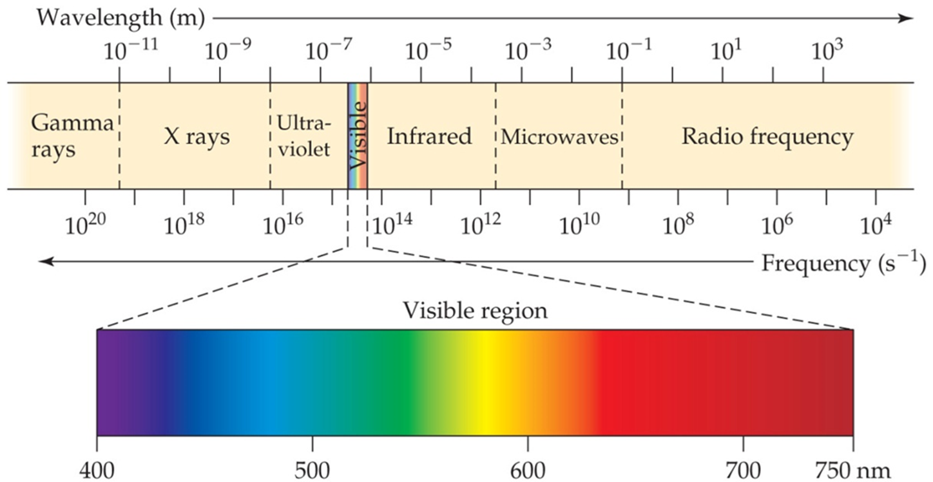

How much light is absorbed or transmitted by a substance can be measured using an instrument called spectrophotometer; the technique is called spectrophotometry. A spectrophotometer consists of a sample holder, a light source and a detector. When a beam of visible light is passed through a substance, the absorbance (A) can be calculated using the equation:
A = -log₁₀ (T)

where T is the transmittance of the sample. Transmittance (T) is the ratio of the transmitted light intensity (I₀) over the incident light intensity (I) and can be expressed as

T = I/I₀

Doing some simple substitution and rearrangement absorbance (A) becomes:

A = -log₁₀ (I/I₀)

where I is the light intensity after the beam of light passes through the sample and I₀ is the light intensity before the beam of light passes through the sample. The absorbance has a logarithmic relationship to the transmittance; with an absorbance of 0 corresponding to a transmittance of 100% and an absorbance of 1 corresponding to 10% transmittance.

Using a standard solution of known concentration (stock solution), we can plot a graph of absorbance versus concentration. Using this graph, we can measure the concentration of an unknown solution and from the data we can calculate the amount of the unknown substance as well. The relationship between the absorbance and concentration is expressed by the Beer-Lambert Law. As the concentration increases the absorbance increases, therefore absorbance is proportional to concentration.

When we plot a graph, the molar absorptivity constant (e) is the slope of the line. This is represented by the equation (Beer-Lambert Law):
A = ebC

- A is the absorbance
- e is the molar absorptivity constant (units are M⁻¹cm⁻¹). It is specific to the substance that is absorbing light at a given wavelength. It represents how much light is absorbed at a particular wavelength.
- b is the path length of the light through the solution. For most standard cuvettes, the path length is 1.00 cm.
- C is the concentration of the solution (M).

If we have solutions of various concentrations of a colored solute, we can measure the absorbance of each solution and then plot absorbance versus concentration. A straight line with a y-intercept of zero and a slope of e times b will yield a standard graph. Using this plot, we can then determine the concentration of the solute in any solution just by measuring its absorbance.

Materials:
- smartphone or iPad with ColorimeterX software

6 test tubes 10ml
- test tube holder
- 2 pipettes, serological 10 ml or syringe 10 ml
- pipette fillers
- piece of red construction paper
- 10 ml blue Gatorade
- 200 ml water
- marker - any color
- Much More than Pretty Colors (1 for every student)
- 25-30 popsicle sticks or craft sticks
- graph paper or computer
- 2 beakers (one for water, one for stock solution)

Pre-Lab Questions:
- What is the unit of concentration of a solution?

- Write the dilution formula:

- Using two 10ml serological pipets/syringe (one for stock solution and 1 for distilled water) and medium test tubes/cups, make the dilutions of the stock solution assigned. Determine the concentration of each of the following dilutions that you will be making when you do the lab as follows

Procedure
Procedure to prepare 10ml of the diluted sample:
- Label 6 test tubes from 1-6.
- Label two clean pipettes, one for measuring water (label 1) and another for stock solution (label 2).
- Measure 10ml of distilled water in test tube one using pipette 1. This is the blank.
- Measure 2 ml of stock solution and transfer to the test tube using pipette 2.
- Measure 8 ml of distilled water using pipette 1 to the test tube
- Mix well.
- Use the dilution formula to calculate the concentration of the diluted solution.
M₁= 6 x 10⁻⁶ (for all)
V₂ = 10 ml (for all)
V₁ from the data table
Substitute and calculate M₂
M₁V₁=M₂V₂
6 x 10⁻⁶ x 2 = M₂ x 10
M₂ = (6 x 10⁻⁶ x 2)/10

Test tube | Volume of the stock solution (ml)  V₁ | Volume of water (ml) | Concentration of the diluted sample(M)  M₁V₁=M₂V₂
1 Blank | 0 | 10 | 0
2 | 2 | 8 | 1.2 x 10 ⁻⁶
3 | 4 | 6 | 2.4 x 10 ⁻⁶
4 | 6 | 4 | 3.6 x 10 ⁻⁶
5 | 8 | 2

B. Construct a spectrophotometer
- With the given popsicle sticks construct a spectrophotometer. (A sample is below.)
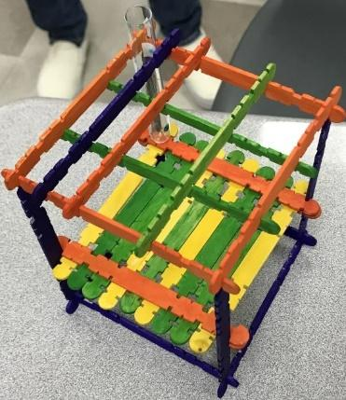
- Download the ColorimeterX app onto your cell phone (iphone app). Go to App Store and search for colorimeter.
- Now you are ready to measure the absorbance.

C. Procedure to measure absorbance:
Set up for measurement
Construction paper
Test tube with sample
Test tube holder

ipad or cell phone
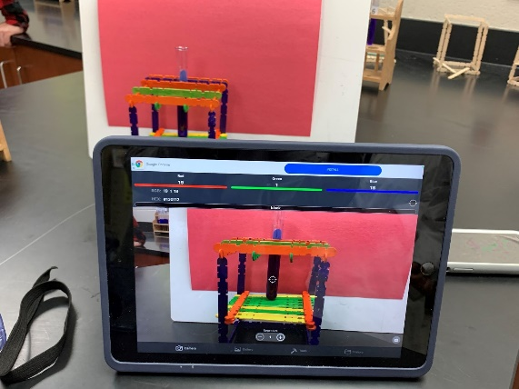
- Take 10ml of the blank (water) and wipe the side to make it clean and dry.
- Place it in the test tube holder you made
- Click on the colorimeter software icon on your phone or iPad
- Tap the camera symbol on your phone or iPad and record the red value on your data sheet.
- Repeat steps 1-3 with diluted samples 2-5.
- Record the data in the data table in the appropriate concentration row.
- Take a picture of your experimental setup and include it in your lab report.
- Calculate the absorbance of the unknown sample.
- Plot a graph on Excel.
  - Graph the data concentration (X axis) Vs. absorbance (Y axis). Provide an appropriate title and label X and Y axis.
  - Enter the values of concentration and absorbance in two columns. Highlight the cells and add scatter plot.
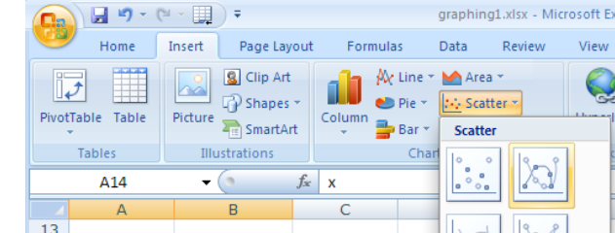
  - This will give you a graph
  - Go to the trend line by right click.
  - Add equation. Display equation. You will get an equation y= mx +c format.
  - Select Linear as the Fit Equation. The best -fit linear regression line will be shown on the graph for your five data points

Procedure to find determine the absorbance value of the unknown beverage solution
Find the absorbance value closest to the absorbance reading you recorded in Step7. The corresponding concentration value is the concentration of the food dye in your unknown sample.

Data Table:
Test tube | Stock Solution  (6 x 10⁻⁶ M) | H₂O (ml) | Concentration (M) | R value | Absorbance=  -log(I/I₀)
1 | 0 | 10 | 0
2 | 2 | 8 | 1.2 x 10 -6
3 | 4 | 6 | 2.4 x 10-6
4 | 6 | 4 | 3.6 x 10-6
5 | 8 | 2 | 4.8 x 10 -6
6 | Gatorade | 0 | from graph

Result
Concentration of the given Gatorade sample =

Post Lab
Answer the questions:
Make sense of what you learned by writing a short reflection about the phenomena you explored, the science and engineering skills you used, and one question or idea you have about what was learned. Answer the prompts in complete sentences:
3 | Three science concepts that I learned and applied in this activity are:
2 | Two science and engineering skills that I used are:
 | Science and Engineering Practices:  ❏ Asking questions (for science) and defining problems (for engineering)  ❏ Developing and using models  ❏ Planning and carrying out investigations  ❏ Analyzing and interpreting data  ❏ Using mathematics and computational thinking  ❏ Constructing explanations (for science) and designing solutions (for engineering)  ❏ Engaging in argument from evidence  ❏ Obtaining, evaluating, and communicating information | Engineering Design Process:  ❏ Ask: Identify the Need & Constraints  ❏ Research the Problem  ❏ Imagine: Develop Possible Solutions  ❏ Plan: Select a Promising Solution  ❏ Create: Build a Prototype  ❏ Test and Evaluate Prototype  ❏ Improve: Redesign as Needed  Engineering Design Thinking:  ❏ Formulating Problems  ❏ Seeking Solutions  ❏ Thriving in Uncertainty  ❏ Collaborating Constantly  ❏ Prototyping Ideas  ❏ Iterating Options  ❏ Reflecting Frequently
1 | One question I have or an idea I would like to further explore is:

