Life-Cycle Assessment Post-Quiz Answer Key
- What is a life cycle?
A life cycle is the various stages something passes through in its lifetime. This might include production, use and disposal of a product or process.
- Name the three main parts of a life cycle assessment (LCA).
  - inventory analysis or accounting stage (collect and calculate data that summarizes all life-cycle inputs and outputs, such as raw materials, supplies, energy, labor, shipping, emissions, etc.)
  - impact analysis (examine life-cycle data to determine the environmental impact, such as energy used and emissions released; compare environmental costs of alternate processes)
  - improvement analysis (interpret impact analysis results and make recommendations that alter the life-cycle decisions and processes in order to reduce a product’s environmental impact)
- Name three main life-cycle stages that cover “cradle to grave.”
Production (including raw material extraction, manufacturing, distribution), use, disposal (waste)
- Which life-cycle stage includes recycling?
Disposal (also production, in cases using recycled materials)
- For each photogaph below, identify its life-cycle stage.
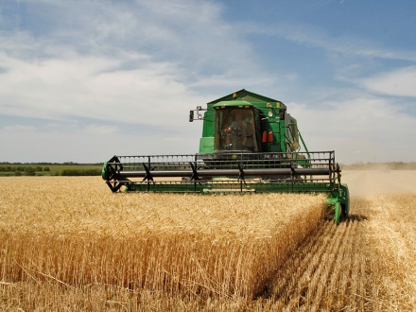
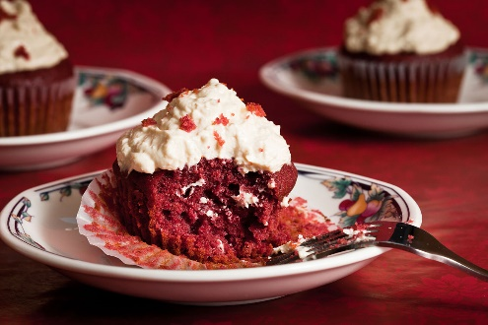
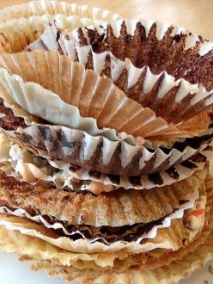
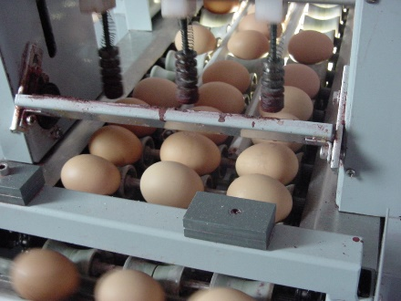

__production________ ___use___________ __disposal______ ___production________
- Why is it important for engineers to use the LCA when designing products?
(Include at least two reasons in your answer.)
(Answers may vary slightly.) Engineers use life cycle assessment to determine 1) all the environmental impacts of a product. They also use the LCA to 2) look at a product’s energy use and air emissions and 3) inform them how to redesign a product to reduce its environmental impact.

- You are making a batch of cupcakes. The recipe calls for 120 ml of milk. If it takes 50 kJ of energy to make 10 ml of milk, how much energy is needed to make 120 ml of milk? (Show your work.)
Hint: 10 ml milk needs 50 kJ of energy
$$120 ml milk ×\frac{50 kJ }{10 ml milk}=600 kJ$$

Energy needed to make 120 ml of milk: ____600 kJ_______________________________

- In the same recipe, you need 2.5 ml vanilla. For every 1 ml of vanilla produced, 4 g CO_{2e} are emitted to the atmosphere. How much CO_{2e} is emitted for 2.5 ml? (Show your work.)
Hint: 1 ml vanilla emits 4 g CO_{2e}
$$2.5 ml vanilla ×\frac{4 g {CO}_{2e} }{1 ml vanilla}=10 g {CO}_{2e}$$

Emissions for 2.5 ml of vanilla: __10 g CO_{2e}_________________________________
Image sources:
(field) 2009 www.volganet.ru, Wikimedia Commons CC BY-SA 3.0 https://commons.wikimedia.org/wiki/File:Agriculture_in_Volgograd_Oblast_002.JPG
(cupcake) 2011 Benson Kua, Wikimedia Commons CC BY-SA 2.0 https://commons.wikimedia.org/wiki/File:Red_velvet_cupcake.jpg
(wrappers) 2009 Joyosity, Flickr CC BY-SA 2.0 https://www.flickr.com/photos/joyosity/3412198095
(eggs) 2002 Narek75, Wikimedia Commons CC BY-SA 4.0 https://commons.wikimedia.org/wiki/File:Dzver.jpg

