Is It Shocking? Worksheet Answer Key
Engineering Challenge: Work together with your classmates to find a material that permits electricity to flow. This material will be used for making solar panels that conduct electricity.
- What type of material are we looking for?
A conductor

- What are some properties of the material that we are looking for?
A material in which electrons flow easily. Metals make good conductors; copper is an example of a good conductor.

Predictions and Testing: Record your predictions and material test results in the table below.
- Make a prediction for the material.
- Rub the material with the cloth.
- Float the material over the tissue paper.
- If the tissue paper moves, the material holds static electricity.

Material | PREDICTIONS | OBSERVATIONS
 | Do you think it will move the tissue paper? | Did it move the tissue paper? | Is it a good conductor?
balloon |  | yes | no
plastic bottle, empty |  | yes | no
plastic bottle,  filled with water |  | yes | no
wooden pencil  or dowel |  | yes | no
rubber eraser |  | yes | no
metal tube/dowel (preferably copper) |  | no | yes
Results
- Which material was the best conductor? Which material is best to use for the solar collector?
The metal materials, copper; these materials do hold a static charge because electrons move freely in conductors.

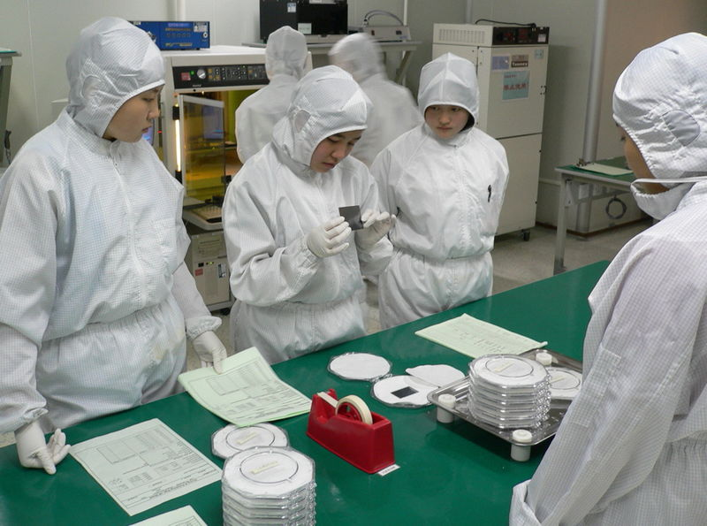
Apply It
Electrical and computer engineers must understand how static electricity builds up and dissipates. In fact, when engineers are designing, prototyping and fabricating semiconductors, which are important and delicate components in computers, they wear jumpsuits made of a material that prevents static electricity from building up. If the engineers had any static electricity on their clothing, they might damage or ruin the semiconductor.
- What type of properties do you think the suits have?
The suits are conductive because conductive material does not build up a charge that could be transferred to semiconductor chips. With conducive materials, any electrical charge quickly dissipates to the ground.

- What evidence from the activity can you use to support your argument?
We know this because the metal was unable to build up charge to move the tissue paper.

- What careers require knowledge of electrical systems so they do not get shocked? Why?
Electricians. They must wear special boots and gloves to prevent accidental electrocution.

- Real-world thinking: In addition to how well a material works as a conductor, engineers also must consider other factors such as cost. For your top three conductors, research the price per pound:
Material | Price per pound | information Source
- For what additional reasons might an engineer choose a different conductor? What if making the conductor was dangerous for the manufacturers or harmful to the environment?
Some factors that influence engineers’ material choices include the material’s toxicity, density (if device weight is a factor), availability; shipping distance, and if the material is a very limited resource. (The point of this question is for students to think deeper about where natural and manufactured materials come from and any associated limitations.)

