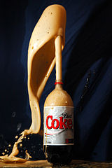
Mentos Fountain Worksheet
In a Mentos® fountain, _______________________ energy stored in the
soda’s carbonation is transferred to ________________________ energy.
Our teacher has designed the following fountain:
Nozzle | Soda Temperature | # of Mentos
x shape | room temperature | 5
We want to design a Mentos® fountain that shoots higher than this one.
Our class is going to work together to design a Mentos® fountain that
shoots as high as possible so we can defeat the teacher in a
head-to-head competition. My group is investigating the effect of
____________________________________________________________________________________.
We will vary _______________________________________, while the other factors remain the same.
We predict that: ______________________________________________________________________.
Run # | Nozzle | Soda Temperature | # of Mentos® | Results
1
2
3
Our prediction was right/wrong. (circle your answer)
Based on our results, we found: _________________________________________________________.
After sharing our results with the other groups, we predict the best fountain design is:
Nozzle | Soda Temperature | # of Mentos®

