Keep It Hot! Handout
Day 1: Introduction
Today, you will study heat transfer by conduction and convection!

Fill in the rest of these statements:

Heat is

Heat always flows from _______________________________ to _______________________________

If we heat up a material (such as water), the molecules begin to

Complete these statements:

Conduction is heat transfer that occurs

Convection is heat transfer

Radiation is heat transfer that is carried by

Label each picture with the type of heat transfer that is occurring:
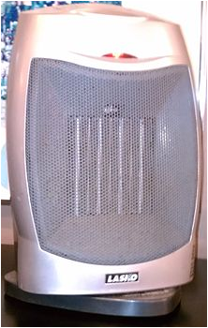

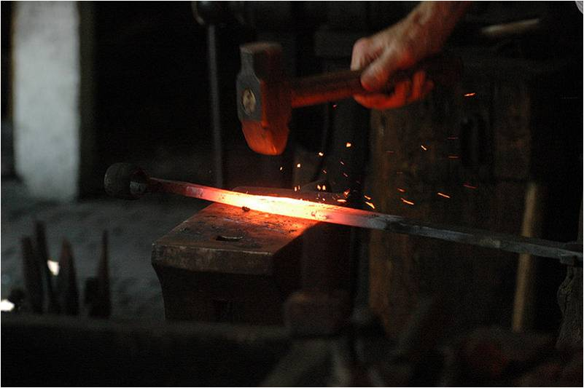
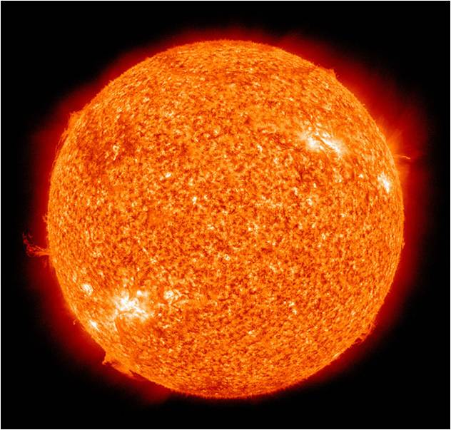

Heat transfer in the rod
Heat transfer through the air
Heat transfer by little packets of energy

______________________ ______________________ ______________________

Questions
Ever wonder why a thermos keeps drinks cool or warm? Or why coffee shops put cardboard sleeves around paper coffee cups? You will find out in this activity! But first, answer these questions:
- What does insulation do?

- The goal is to prevent heat from leaving your bottle. What types of materials do you think would be good at this? List them below.

- Does the thickness of your insulation matter? Explain what you think would happen if you double the amount of insulation used on each bottle.

Vocabulary
heat
heat transfer
conduction
convection
radiation
insulation

Your Engineering Challenge
To create insulated bottles to keep water hot as long as possible.
To do this, your group will create and test different insulated bottle designs.

Design
You will test three materials for insulation of a plastic bottle. You will also test a bottle with no insulation to provide a point of comparison (control). You are welcome to bring in materials from home to test, but you will be provided with the following materials in class.

Materials
- 4 plastic bottles with tight fitting lids
- test insulation materials, such as aluminum foil, construction paper/tag board, felt, bubble wrap
- hot water
- thermometers, one per bottle (or share among groups)
- house fan (share among groups)

Team Brainstorming-Thinking-Researching
- The goal is to prevent heat from leaving your bottle. What types of materials do you think would be good at this? List them below.

- Does the thickness of your insulation matter? Explain what you think would happen if you double the amount of insulation used on each bottle.

Day 2 Procedure: Build and Test 1 - Cooling with No Fan
- Apply a different insulation material (using tape) to each of your bottles. If more than one layer is added, make sure to add the same number of layers for each material.
- Your instructor will fill each of your bottles with hot water. Seal the lids tightly and do not open them since water at this temperature can burn skin.
- Place a thermometer in one bottle and record the temperature in the table below. At the beginning, all of your bottles are the same temperature so record this number in all four boxes.
- Wait 10 minutes and record in the table below the temperatures of all the bottles.
- Calculate the change in temperature and enter in the appropriate column of the table below. Answer the Results and Discussion questions below
Note: With the help of your teacher, discard the water and set aside your bottles for Day 3.

Day 2 Data Collection
With no fan blowing, record your data:
Insulation Material (and # of layers) | Beginning temperature (show units!) | Temperature  after 10 minutes | Change in temperature
Control (no insulation)
Day 2 Results and Discussion
- What material kept the water hottest?

- Is this what you expected?

Day 3 Procedure: Test 1 - Cooling with Fan
- Position the same bottles used the previous day in front of a fan.
- Your instructor will fill each of your bottles with hot water. Seal the lids tightly and do not open them since water at this temperature can burn skin.
- Place a thermometer in one bottle and record the temperature in the table below. At the beginning, all of your bottles are the same temperature so record this number in all four boxes.
- Switch on the fan, wait 10 minutes, and then record in the table below the temperatures of each bottle.
- Calculate the change in temperature and enter in the appropriate column of the table below. Next, answer the Results and Discussion questions below.
Day 3 Data Collection
With the fan blowing, record your data in the following table.
Insulation Material (and # of layers) | Beginning temperature (show units!) | Temperature  after 10 minutes | Change in temperature
Control (no insulation)

Day 4 Results and Discussion
- What material kept the water hottest? Is this what you expected?

- Did heat transfer occur faster or slower when the fan was on?

- What kinds of heat transfer occurred when the fan was on? Explain where each type was occurring.

- What kind/s of heat transfer was/were occurring when the fan was off?

- Can you explain the difference?

- How did increasing convection affect the rate of conduction and why?

- Suggest a modification (change) you would make to your best insulation to reduce heat transfer even more. Would this change the cost ($) of manufacturing (making) your bottle?

Connect It
Using your knowledge of heat transfer, why do you feel warmer when you wear a jacket in the winter? (What is the jacket doing?)

