Keep It Hot! Handout Answer Key
Day 1: Introduction
Today, you will study heat transfer by conduction and convection!

Fill in the rest of these statements:

Heat is the transfer or flow of thermal energy.

Heat always flows from hot or higher temperature to cold or lower temperature.

If we heat up a material (such as water), the molecules begin to move faster (and collide more frequently).

Complete these statements:

Conduction is heat transfer that occurs within a solid or between two solids.

Convection is heat transfer into and out of fluids (gases or liquids).

Radiation is heat transfer that is carried by little packets of energy called photons.

Label each picture with the type of heat transfer that is occurring:
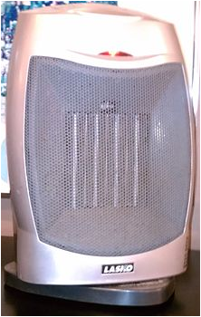

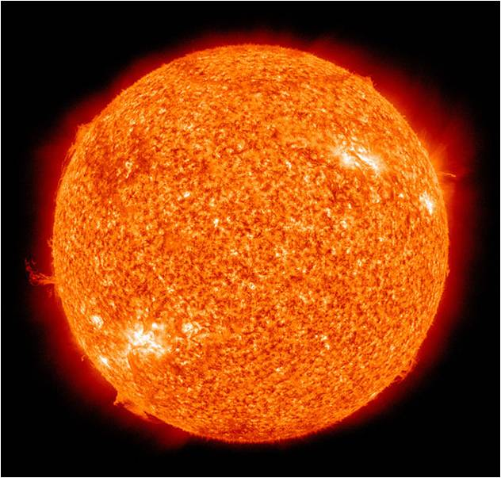
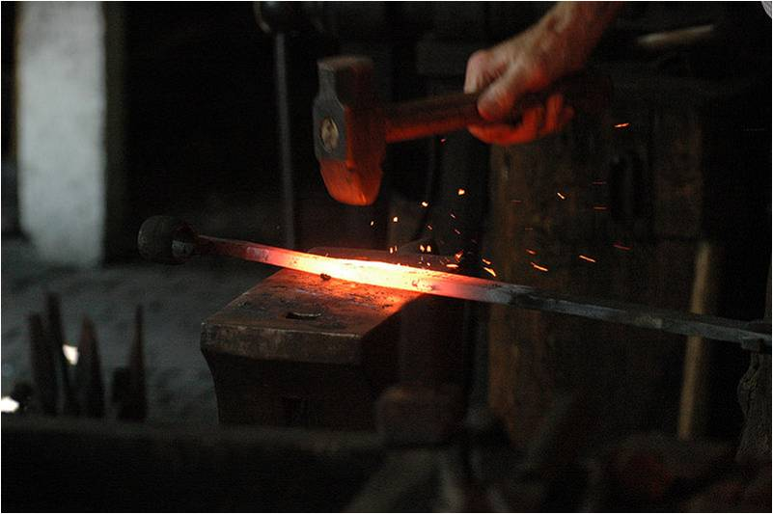

Heat transfer in the rod
Heat transfer through the air
Heat transfer by little packets of energy

convection conduction radiation
Questions
Ever wonder why a thermos keeps drinks cool or warm? Or why coffee shops put cardboard sleeves around paper coffee cups? You will find out in this activity! But first, answer these questions:
- What does insulation do?
Insulation slows down the rate of heat transfer. It does NOT make things hot or cold; it only slows changes in temperature.
- The goal is to prevent heat from leaving your bottle. What types of materials do you think would be good at this? List them below.
(Have students use their intuition about what might be good insulation. Can they relate their intuition to what they have learned in the associated lessons?)
- Does the thickness of your insulation matter? Explain what you think would happen if you double the amount of insulation used on each bottle.
(Encourage students to think about whether or not it is possible to stop the flow of heat completely. If adding the insulation were to cut the rate of heat loss in half, for example, would doubling that amount of insulation stop the OTHER half? The error in this thinking may not be obvious to them.)

Vocabulary
heat
heat transfer
conduction
convection
radiation
insulation
Your Engineering Challenge
To create insulated bottles to keep water hot as long as possible.
To do this, your group will create and test different insulated bottle designs.

Design
You will test three materials for insulation of a plastic bottle. You will also test a bottle with no insulation to provide a point of comparison (control). You are welcome to bring in materials from home to test, but you will be provided with the following materials in class.

Materials
- 4 plastic bottles with tight fitting lids
- test insulation materials, such as aluminum foil, construction paper/tag board, felt, bubble wrap
- hot water
- thermometers, one per bottle (or share among groups)
- house fan (share among groups)

Team Brainstorming-Thinking-Researching
- The goal is to prevent heat from leaving your bottle. What types of materials do you think would be good at this? List them below.

- Does the thickness of your insulation matter? Explain what you think would happen if you double the amount of insulation used on each bottle.

Day 2 Procedure: Build and Test 1 - Cooling with No Fan
- Apply a different insulation material (using tape) to each of your bottles. If more than one layer is added, make sure to add the same number of layers for each material.
- Your instructor will fill each of your bottles with hot water. Seal the lids tightly and do not open them since water at this temperature can burn skin.
- Place a thermometer in one bottle and record in the table below its temperature. At the beginning, all of your bottles are the same temperature so record this number in all four boxes.
- Wait 10 minutes and record in the table below the temperatures of all the bottles.
- Calculate the change in temperature and enter in the appropriate column of the table below. Answer the Results and Discussion questions below
Note: With the help of your teacher, discard the water and set aside your bottles for Day 3.

Day 2 Data Collection (no fan)
With no fan blowing, record your data:
Insulation Material (and # of layers) | Beginning temperature (show units!) | Temperature  after 10 minutes | Change in temperature
Control (no insulation)
Day 2 Results and Discussion
- What material kept the water hottest?
Answers will vary.

- Is this what you expected? Explain.
The expected order of effectiveness might be: bubble wrap, construction paper/tag board, aluminum foil (given those three materials).

Day 3 Procedure: Test 2 - Cooling with Fan
- Position the same bottles used the previous day in front of a fan.
- Your instructor will fill each of your bottles with hot water. Seal the lids tightly and do not open them since water at this temperature can burn skin.
- Place a thermometer in one bottle and record the temperature in the table below. At the beginning, all of your bottles are the same temperature so record this number in all four boxes.
- Switch on the fan, wait 10 minutes, and then record in the table below the temperatures of each bottle.
- Calculate the change in temperature and enter in the appropriate column of the table below. Next, answer the Results and Discussion questions below.
Day 3 Data Collection (with fan on)
With the fan blowing, record your data in the following table.
Insulation Material (and # of layers) | Beginning temperature (show units!) | Temperature  after 10 minutes | Change in temperature
Control (no insulation)

Day 4 Results and Discussion
Note: Comments in parentheses are suggestions to the teacher, not answers.
- What material kept the water hottest? Is this what you expected?
(The order of effectiveness does not tend to change from that of the previous run. What does change is the rate of cooling)

- Did heat transfer occur faster or slower when the fan was on?
(Expect the heat transfer rate [that is, cooling] to increase when the fan is applied as evidenced by the water temperature dropping more quickly with the fan turned on, especially in the bottle with no insulation.)

- What kinds of heat transfer occurred when the fan was on? Explain where each type was occurring.
Conduction occurred through the wall of the bottle and through the insulation; forced convection occurred in the air surrounding the bottle. Introduction of the fan greatly increases the heat transfer by convection at the surface of the bottle/insulation. This increased convection causes a corresponding increase in conduction within the boundaries of the bottle walls/insulation.

- What kind(s) of heat transfer occurred when the fan was off?
Both conduction and convection occurred when the fan was off, as above, but at much lower rates.

- Can you explain the difference?
The difference is the velocity of the air surrounding the bottle. Increased airflow causes increased convection.

- How did increasing convection affect the rate of conduction and why?
Conduction also increases. (Since, in this case, conduction and convection are in series, one cannot occur without the other [imagine blocking one end of a water hose causing flow to stop at the other end as well]. Increasing the rate of one will necessarily cause an increase in the other.)

- Suggest a modification (change) you would make to your best insulation to reduce heat transfer even more. Would this change the cost ($) of manufacturing (making) your bottle?
(Encourage students to think about diminishing returns [that is, the cost of insulation is linear, where the savings due the decrease in heat loss is not]. Discuss the cost vs. performance trade-off.)

Connect It
Using your knowledge of heat transfer, why do you feel warmer when you wear a jacket in the winter? (What is the jacket doing?)
The jacket makes you feel warmer, not because it provides any warmth (thermal energy), but because it is an INSULATOR that slows the rate of heat transfer from the surface of the skin.

