Sliding Textbooks Worksheet Answer Key
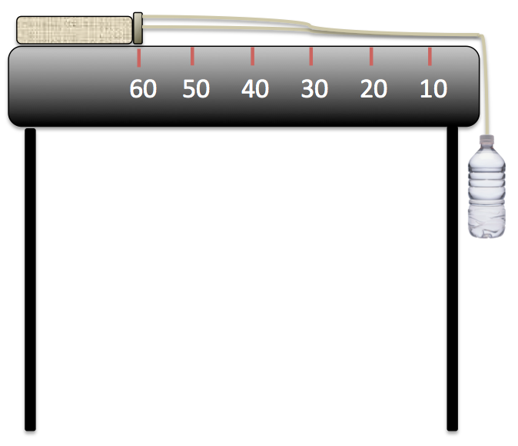
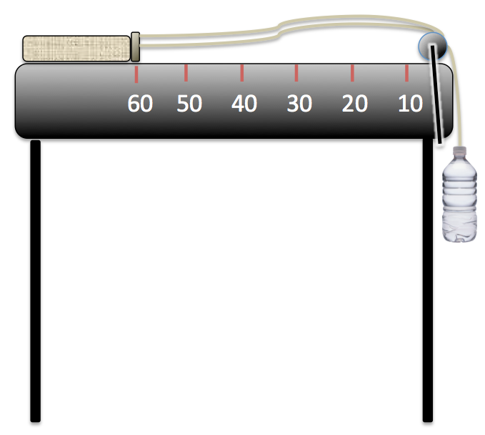
Sliding Textbooks: An Experiment Exploring the Nature of Forces, Friction and Acceleration Due to Gravity

Setup without pulley. Setup with pulley.

Materials List (for each group)
- table or desk
- string, a bit more than 2 meters
- measuring tape, at least 1 meter long
- stopwatch
- textbook weighing 0.5-0.75 kg
- ~60 cm (~24 in) length of one material; choose from wax paper, plastic wrap, baking parchment paper, aluminum foil (or any other provided by the teacher)
- tape
- plastic soda bottle, 12 oz size (≈ 355 ml), with a small hole pierced in the bottle cap
- water and graduated cylinder
- graph paper
- (optional) pulley with table clamps
Experiment Setup & Overall Procedures
- Measure 60 cm from the table edge, and place the spine of the textbook at the 60 cm mark.
- Loop the string around the spine of the textbook.
- Tie the two ends of the string together just above the bottle cap.
- Pierce a small hole in the middle of the bottle cap, just large enough to thread the string through.
- Thread the string through the top of the bottle cap, and tie a knot to secure it.
- In each of the following replications of the experiment, fill the bottle with the indicated volume of water. Then screw the cap onto the water bottle, holding the bottle (do not let the bottle hang yet). Start the stopwatch at the moment the water bottle is released. Stop the watch when the spine of the textbook reaches the 10 cm mark. Record the time on the worksheet, along with observations.
- Time each run (at every volume of water) three times.

Observations & Measurements
Experiment 1
Expect the average times to decrease as more water is added to the bottle. Depending on the mass of the book and the surface (friction), smaller volumes of water (lower masses) will not be enough to overcome the static coefficient of friction, and the book will not slide. It is recommended that the teacher experiment in advance to find the right book and water volume(s) to get this intended effect. Example times are given below in red.
Fill the bottle with 125 ml of water. Observe what happens. Does the book slide? Why or why not?
If the book does not slide, it is due to the static frictional force not being overcome.
A. If the book slides, repeat the experiment three times, and record the time to go from 60 cm to 10 cm:
Trial 1: __34 secs__ Trial 2: __30___ Trial 3: __32___

Now fill the bottle with 150 ml of water. Does the book slide? Why or why not?
____________________________________________________________________________________
B. If the book slides, repeat the experiment three times, and record the time to go from 60 cm to 10 cm:
Trial 1: __26___ Trial 2: __24___ Trial 3: __22___

Now fill the bottle with 175 ml of water. Does the book slide? Why or why not?
____________________________________________________________________________________
C. If the book slides, repeat the experiment three times, and record the time to go from 60 cm to 10 cm:
Trial 1: __12___ Trial 2: __10__ Trial 3: __8___

Now fill the bottle with 200 ml of water. Does the book slide? Why or why not?
____________________________________________________________________________________
D. If the book slides, repeat the experiment three times, and record the time to go from 60 cm to 10 cm:
Trial 1: __8__ Trial 2: __4___ Trial 3: __6__
Experiment 2
In this experiment, you explore the effect of different surfaces on the amount of friction exerted on the book. Your engineering challenge is to determine which material will make the best “runway” so your book can accelerate the fastest.
Choose from wax paper, plastic wrap, baking parchment paper, aluminum foil.
Prediction: How do you think the runway made from the material you chose will affect the acceleration of the textbook?
Expect students to write about the fact that these surfaces, if more smooth than the table, will decrease the coefficients of static and dynamic friction.

Tape the material to the tabletop. Follow the Experiment 1 procedures, recording your time measurements and observations, but this time with the new surface in place.
Expect that the average times decrease compared with Experiment 1 (above), assuming that the material chosen has lower coefficients of friction than the table. Expect the minimum volume of water needed to overcome the static coefficient of friction to likely also decrease.

Fill the bottle with 125 ml of water. Observe what happens. Does the book slide? Why or why not?
If the book does not slide, it is due to the static frictional force not being overcome.

A. If the book slides, repeat the experiment three times, and record the time to go from 60 cm to 10 cm:
Trial 1: __30 secs__ Trial 2: __26___ Trial 3: __28___

Now fill the bottle with 150 ml of water. Does the book slide? Why or why not?
____________________________________________________________________________________
B. If the book slides, repeat the experiment three times, and record the time to go from 60 cm to 10 cm:
Trial 1: __22___ Trial 2: __20___ Trial 3: __18___

Now fill the bottle with 175 ml of water. Does the book slide? Why or why not?
____________________________________________________________________________________
C. If the book slides, repeat the experiment three times, and record the time to go from 60 cm to 10 cm:
Trial 1: __8___ Trial 2: __6__ Trial 3: __4___

Now fill the bottle with 200 ml of water. Does the book slide? Why or why not?
____________________________________________________________________________________
D. If the book slides, repeat the experiment three times, and record the time to go from 60 cm to 10 cm:
Trial 1: __4__ Trial 2: __1___ Trial 3: __4__
Calculations
How far did the textbook travel going from the 60 cm mark to the 10 cm mark? _____50 cm_____
Call this distance “d.”
Average the times for each trial (A, B, C, D in Experiment 1, and E, F, G and H in Experiment 2). Record the average times in the table below.
Next, use these average times, together with the distance traveled, to calculate the average acceleration using the equation: a = 2d/t², where d is distance and t is time.
 | Avg Time (t) | Avg Acceleration (a) |  |  | Avg Time (t) | Avg Acceleration (a)
A | 32 seconds | 0.098_cm/s² |  | E | 28 seconds | 0.128_cm/s²
B | 24 seconds | 0.174_cm/s² |  | F | 20 seconds | 0.250_cm/s²
C | 10 seconds | 1.000_cm/s² |  | G | 6 seconds | 2.778_cm/s²
D | 6 seconds | 2.778_cm/s² |  | H | 3 seconds | 11.11_cm/s²

Results
Weigh the empty water bottle. Knowing that 1 ml of water ≈ 1 gram (at 4 °Celsius, the equation is exact), calculate the mass of the bottle filled with water at each volume of water.
The result will be the mass of the water bottle (in grams), plus the volume of water. So if the empty water bottle is 10 grams, then the answers are:
125 ml plus bottle = __135____ kg 175 ml plus bottle = __185____ kg
150 ml plus bottle = __160____ kg 200 ml plus bottle = __210____ kg

Analysis Questions
- When you put more mass (water) into the soda bottle, what happens to the average acceleration (does it get faster or slower)? Why?
It gets faster as a result of a greater force, which is the result of a larger mass working on the textbook (times the vector component of acceleration due to gravity, and minus the coefficient of dynamic friction).

- On graph paper, plot the points from the first experiment (without the runway) and connect them as a line. Do the points lie perfectly in a line? Why or why not?
Since acceleration is the product of the (net) force times the mass, assuming the friction of the table surface is constant, that is, if the table is of uniform “smoothness” (which is a big assumption!), then the graph of the points should approximate a straight line. This is unlikely to be the case in practice, however. But the trend should be clear. Give credit for any thoughtful answer discussing the “why” question that show the use of relevant vocabulary and concepts.

- What difference do you see between Experiment 1 (the table and book) and Experiment 2 (with the “runway”)? Did the textbook accelerate faster or slower with the new material (wax paper, plastic wrap, baking parchment paper or aluminum foil) runway surface? Why?
If the new surface is smoother than the table surface (as is typically the case), then the volume of water needed to overcome the static coefficient of friction is smaller, and the book accelerates faster, in Experiment 2. This is because the frictional force is smaller, and so the net force acting as the product of gravity and the mass of the water plus bottle (minus the frictional force) is greater.

- For what types of situations might you want a smooth material?
If the extension with pulleys was done, discuss the design of pulleys. In rope and pulley applications, you do not want much friction. Smooth surfaces are useful for highways and have a big impact on the fuel economy of cars and trucks—but highways must not be made too smooth because tires need to grip the road! In mechanical devices, such as car motor pistons or lock mechanisms, lubricants are used to reduce friction.

- For what types of situations might you want a rough material?
Staying with the example of automobiles, brakes rely on friction to catch and quickly stop car wheels. Materials like Velcro, as well as soft natural or synthetic rubber types and other polymers, are often used for shoe soles, car tires and sport gloves (such as for rock climbing and racket sports).

