Kinetic and Potential Post-Quiz Answer Key
- If I double the mass of a moving object, what happens to the object’s energy?
Its energy doubles.

- If I double the velocity of a moving object, what happens to the object’s energy?
The energy increases as a factor of 4 (2²).

- Match the type of potential energy to the illustration:
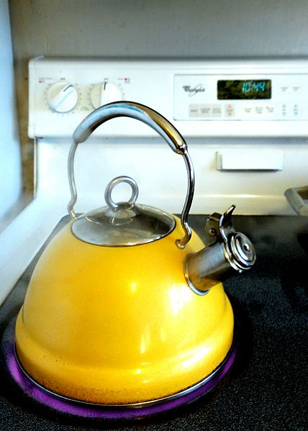
chemical energy

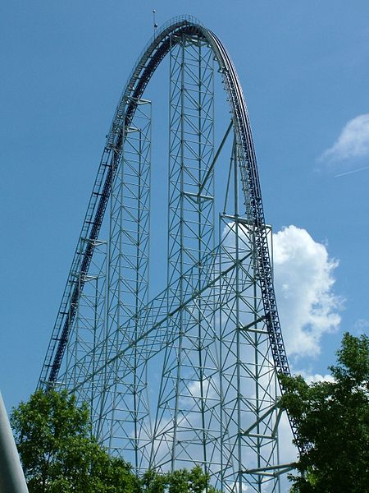
elastic energy

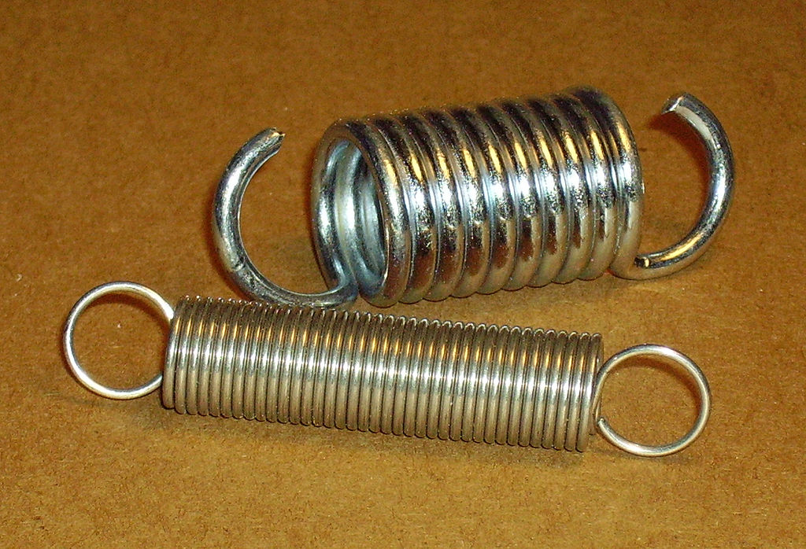
gravitational energy

thermal energy

