What is a Wave? Post-Assessment Key

Directions
Answer the following questions the best you can. This is a graded assignment.

Given the equation for a sine wave below, answer the following questions:

$$y\left(t\right)=4.5\sin\left(6πt+45\right)-15$$

- What is the frequency of the wave?
6*pi / 2*pi = 3

- What is the phase angle of the wave, and how does this phase angle affect the graph of the wave? -45, the wave is shifted to the left by 45

Given the plot for a sine wave below, answer the following questions (assume the phase angle and vertical shift are equal to 0):

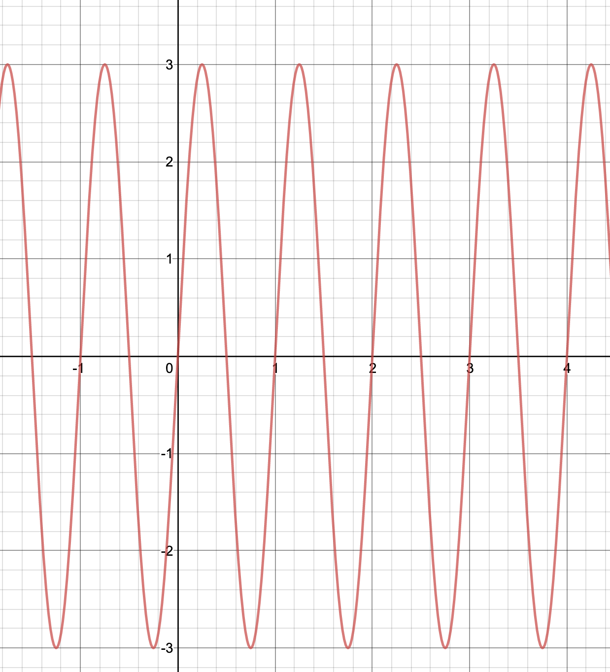

- What is the amplitude of the sine wave?
3

- What is the frequency of the sine wave? How did you calculate it?
1, there is exactly one cycle per second

