What is a Wave? Pre-Assessment

Directions
Answer the following questions the best you can. You are not expected to know the answers, and this
assignment will not be graded.

- List two examples of waves.

- What is the amplitude of the following sine wave?

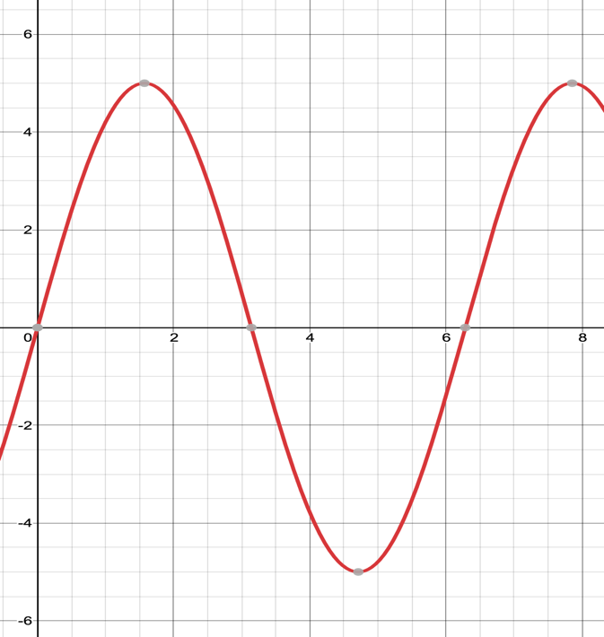

- Describe the frequency of a wave and how increasing or decreasing the frequency affects a wave.

- How does introducing a negative phase angle affect the graph of a sine wave?

