Navigating a Maze Worksheet Answer Key
Answer the following questions related to the program design:
- Define the task you would like to perform:
We want the robot to go through the maze by moving along the indicated path without hitting the walls.
- Write a set of instructions in English (such as: go forward X inches, turn Y rotations left, etc.) that the robot needs to do to successfully navigate the provided maze structure.
- Move forward for 36 inches
- Turn left 90°
- Move forward for 18 inches
- Turn right 135°
- Move forward for 24 inches
- Turn left 135°
- Move forward 36 inches
- Stop
- Are other solutions possible?
No, not really. To travel through the maze, all robots should approximately follow the above set of directions. However instead of turning left X degrees, one can turn right 360 – X degrees. Note also that step 8 is optional as it is implied that the robot stops after each previous step.

Answer the following questions related to the EV3 software:
- What are the three choices for the “Direction” option on a Move Block?
The three choices are: forward, backward, stop.

- What does “Steering” control? How do you change the steering?
Steering allows us to easily make the robot turn. Dragging the pointer to the left makes the robot turn left, and dragging it to the right makes the robot turn right.
The farther to one side the pointer is dragged, the sharper the turn will be; if the pointer is dragged all the way to one side, the robot should turn in place.

- What does “duration” mean? What is a rotation?
“Duration” is another way of saying: For how long will an action occur? It is a period of time. In this case, duration means how long the motors rotate.
A rotation is one full spin of the motor.

- How many inches does one rotation typically make the robot move?
Approximately 7

- Assuming that the steering pointer pulled all the way in one direction, how many rotations is generally a good, 90-degree turn?
0.5 rotations

- Brainstorm about possible programming solutions and write below the one that your group thinks is a good one.
Example approximate solution:
- Move forward 5 rotations
- Turn left 0.5 rotations
- Move forward 2.5 rotations
- Turn right 0.75 rotations
- Move forward 3.5 rotations
- Turn left 0.75 rotations
- Move forward 5 rotations
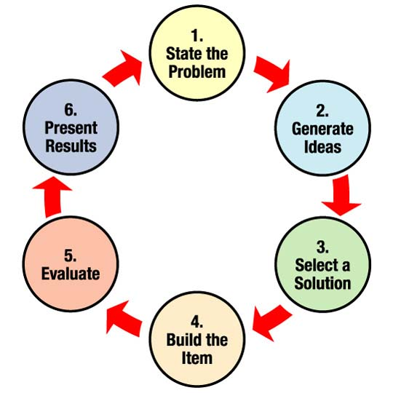
- Did you have to “iterate” (make changes to the program, etc.) to make it work?
How many iterations did you have to perform?
Example answer: Yes, we had to iterate several times. Our second turn was too small so we modified step 4 to “Turn 0.8 rotations.” Then in step 5, the robot turned too early so we increased the duration to 4 rotations instead of 3.5.

