What Is Bluetooth? Worksheet
Part 1
- What is an electrical connection?

- Give two examples of electrical connections.

- What is the difference between wired and wireless connections?
What is an advantage of using wireless connections?

- What is the name of the wireless electrical connection that the EV3 can make?

Part 2
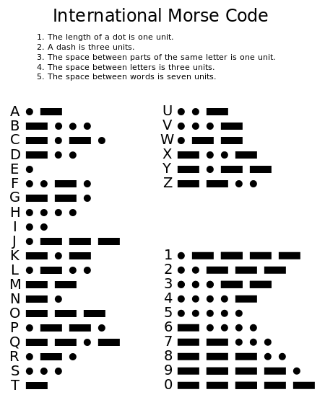
Here are some examples:
(Note: a slash / is used between words)

“Hello” in Morse code is:
.... . .-.. .-.. ---
“How are you?” is:
.... --- .-- / .- .-. . / -.-- --- ..-
Write the Morse code for the following:
- “This is fun”

- “Thank you”

- “I love you”

- “Move on”

Source of Morse code chart: http://en.wikipedia.org/wiki/Morse_code

