Circuit Card Company Consultation Report Answers

Background: The Circuit Card Company (CCC) has been making its light-up LED cards using copper tape. The tape works well but is time consuming to apply. The company has just acquired a screen-printing machine that it believes will speed up the card making process. It has contracted with your engineering firm to design a new card using stencils and conductive paint.

Your job is to produce a prototype and report!

Step 1. Reverse Engineering: How does an existing CCC card work?
With a partner, carefully reverse-engineer an existing Circuit Card Company copper tape card circuit to see how it works. Write your answers to the questions below.

- How do you turn the circuit on?
Push on the card over the battery.
- What prevents the circuit from being on all the time?
The stiffness of the cardstock and LED wire keep the two sides from touching all the time.
Carefully take the circuit apart by opening it and untaping one side.

- Which side of the battery is pointing down (positive or negative)?
Positive.

- Is the battery completely taped over or is most of it exposed?
Most of it is exposed.

Look closely at an LED.

Which LED wire in the circuit is connected to the copper tape in contact with the positive side of the battery? The longer one.

Draw a picture of the circuit below. Carefully note which side of the battery is positive and which LED wire is attached to the positive side of the battery.
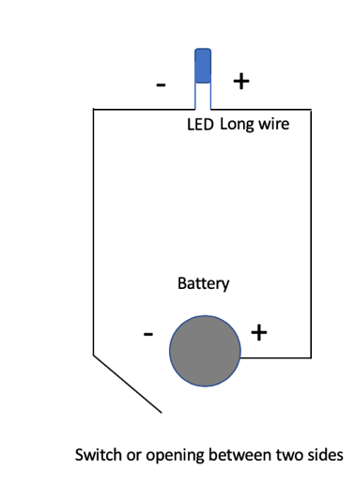
Try drawing the circuit using the following symbols for each part.

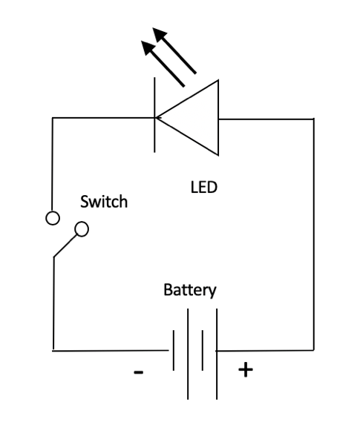

The circuit does not work when the card is open.

- When the card is closed and you push down on it, how does the copper tape on the left side connect to the negative side of the battery?
The tape on the left side touches the exposed, untapped, top part of the battery.

- What does this tell you about how the two pieces of conductive tape need to be positioned on the card with respect to the battery? The left tape must be lined up so that it touches the battery when the card closed.

Notice that the pieces of scotch tape holding the LED wires completely covers them and that the two LED wires do not touch.

- Why do you think this is important? So that the two LED wires do not touch each other and short out the LED. The electrons have to flow through the LED chip, not circumvent it by flowing directly between the wires.

Notice that there is a hole for the LED and a pen mark on the inside right side.

- Do you think they are related? Yes. If you close the card, the pen mark lines up exactly with the hole for the LED. In fact, that is how the pen mark was made.

- Do you think they might be important for the card construction and tape alignment? Yes, the pen mark is a “registration mark” that tells you where to put the stencils so that the conductive paint traces are lined up correctly. The inside stencils go right under the LED hole and the pen mark and then they go straight down. This way the battery pads on the two sides will line up and the LED wires will attach to the traces in the right places.

Step 2. Conductive Paint Prototype: Painting.
Now that you understand how this circuit works, go to the resource table to design and make a sample card using a conductive paint. Each student should complete her/his own.
[Optional Extension 2: The company wants a complete card; the front cover will be a LED circuit that can be pushed on, and then the larger card will open for a message inside.]
HELPFUL HINTS
- Make sure your stencil is sticking tightly and smoothly to the cardstock before you apply the paint.
- Apply a thin coat of paint and LEAVE THE STENCIL ON UNTIL THE PAINT DRIES (ABOUT 15 MINUTES).
- A blow dryer may help the card dry faster.

Step 3 Assembling the Prototype.
First put a battery in between a LED to make sure that both work. You’ll notice that the LED allows electricity to flow in one direction only. That is what a DIODE does. LEDs emit light. That is why they are called Light Emitting Diodes.

Put your complete card together. Does it work? If not, go over your observations from Step 1 with your partner or look at a CCC copper tape card to make sure you have assembled the card correctly.

You may remind students not to cover their entire battery with tape, but only a small part.
It helps to figure out which side the long LED wire will be attached to. If the battery is facing down on the right-hand side, the long wire will go on the far-right side. Then the LED should go through the hole with the long lead on top and the short lead facing down. Once through the hole the short lead is bent down and taped down to the left-hand side paint trace. The tape should not cover the battery pad. Then the students can put a piece of tape on top of the taped LED with the sticky side pointing up, bend down the long LED onto the sticky side and carefully close the card so that the long LED wire adheres to the paint trace on the right-hand side. Again, the tape should not be so long that it covers up the battery.

Troubleshooting:
- Is the long end of the LED connected to the positive side of the battery? Easy way to check that is to turn the battery over.
- Is the LED shorting out? Make sure the two LED leads are not touching and that scotch tape is covering the entire lengths of the wires
- Is the battery totally covered with scotch tape? Make sure most of it is exposed.
- Is the battery pad on the left-hand side aligned with the battery on the right hand side when the card is closed?

Optional Extension 1: Resistance Measurements
The brightness of the LED depends on how much current is going through it. This in turn depends on the voltage of the battery and how easily the “wires” between the battery and the LED allow electricity to flow. This last quality is called the “resistance” of the wire. Using a multimeter measure the resistance of the copper tape. Set the multimeter at the 200 Ω (Ohm) scale and put the leads at either end. Record your measurements below:
Your values may vary

Copper Tape Resistance (1.8 ohms – your values)

Copper Tape Current (1.6 amps – your values)
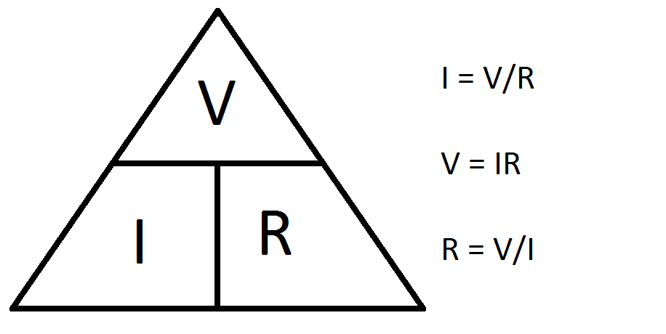
Conductive Paint Resistance copper paint ~13 ohms; carbon paint ~
Conductive Paint Current copper paint 0.23 amps; carbon paint

We can calculate the current using an equation called Ohms Law.

Current (I, amps) = Voltage (volts) /Resistance (ohms) = _____________

Look at (or measure) the voltage of your battery and calculate the current (I) that goes through the LED using the copper tape.

When your prototype dries measure the resistance of a conductive paint trace from two ends. You may need to turn the dial to the 2000 ohm scale if you are using black carbon paint. Calculate the current going through your circuit and record it above. (The paint takes 24 hours to completely dry and reach its best conductivity - lowest resistivity). If project time allows , wait 24 hours to get a more accurate reading.

- Why do you think the meter jumps around so much? The paint is less dense and not as regular as the copper tape so as one measures, different electrical paths are continuously forming and the contact with the probes is not as good or as consistent.

- Which material has the most resistance, the copper tape or the conductive paint? The paint has more resistance. This means that the LEDs will be less bright with the conductive paint

- What does this mean in terms of LED brightness? The LEDs will be less bright with the conductive paint

- Assuming the brightness is proportional to the current flow how much brighter is the copper tape?

Copper Tape Current =
6.95 times brighter than copper paint;
Conductive Paint Current

- Can you see the difference? Yes.

Step 5. Optional Extension 3: Two-LED Card.
CCC now wants you to design a card for two LEDs and one 3-volt battery. Using the circuit elements, attach 2 LEDs in series (1 path) and then try 2 in parallel (2 path), as shown in the diagrams below.

- Which configuration made the brightest LEDs? The parallel circuit produces brighter LEDs.

Draw a card design for a 2 LED circuit.

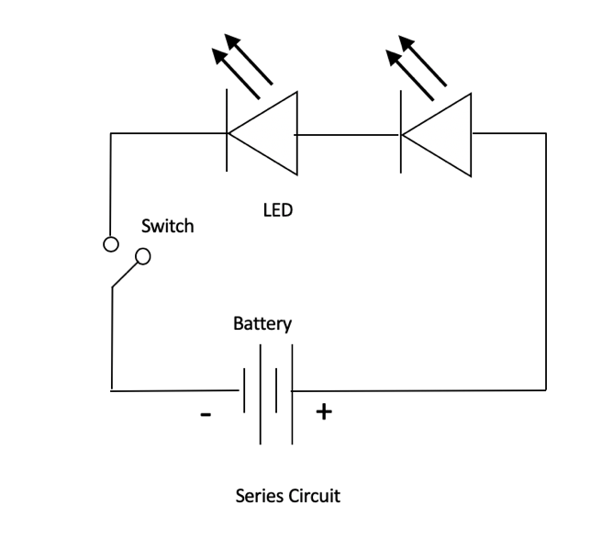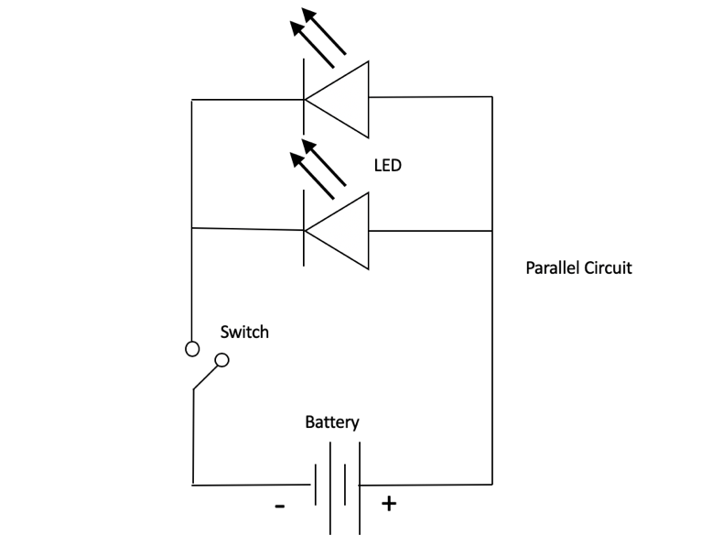

One possibility:
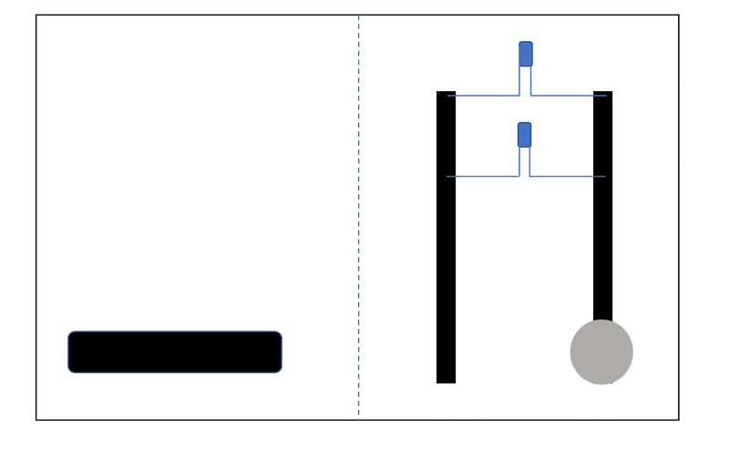Dotted line is fold.

Try out your design using copper tape. Does it work?

