Trigonometry via Mobile Device Activity –
Post-Activity Quiz

Directions
Using the illustration and description below, prepare well-written statements — including all necessary trigonometric equations — to answer the following questions.
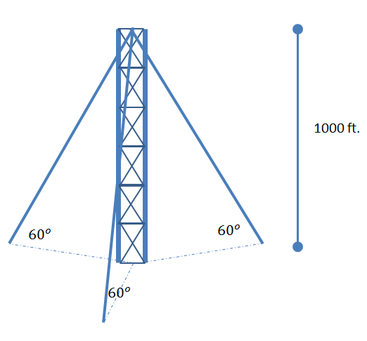
A 1000 ft. radio tower is to be supported by three evenly spaced guy wires.
Each wire will make a 60 degree angle with the ground.

Questions
- Approximately how many feet of cable will be needed to construct the tower?

- How far will each wire be away from the tower?

- What is the total surface area on the ground needed to build the tower (in other words, what is the area of the triangle formed on the ground by the wire anchors)?

