Explain a Rube Goldberg Machine

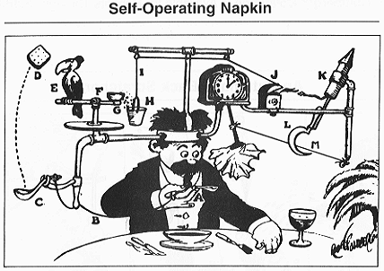

Look carefully at the cartoon drawing and analyze how the system works. Write down an explanation of how you think the machine works. Be specific in your analysis and explanation.
Try to capture every step!

