Explain a Rube Goldberg Machine
Example Answer

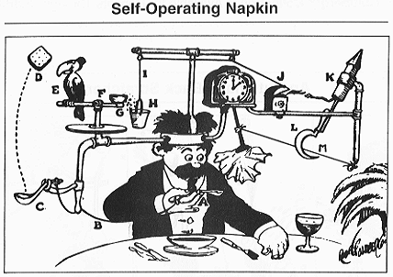

Look carefully at the cartoon drawing and analyze how the system works. Write down an explanation of how you think the machine works. Be specific in your analysis and explanation.
Try to capture every step!
To begin, the man moves the spoon up to his mouth. This causes a lever to move, releasing a spring that is connected to a spoon. The stored energy in the spring causes the spoon to flip a piece of toast into the air. When the toast is in the air, a bird flies to catch it. The bird flying away upsets the balance on a “teeter totter,” dumping a liquid into a bucket. The liquid makes the bucket heavier, causing the bucket to lower. The movement of the bucket triggers a lighter to open and strike a flame. The flame lights a rocket that takes off. The rocket is connected to a sickle that cuts a string that is attached to a pendulum that is powered by a clock. At the end of the pendulum, a napkin is attached. When the pendulum moves back and forth (due to the clock’s power), it wipes the man’s face with the napkin.
Image source: 1915 Wikimedia Commons http://commons.wikimedia.org/wiki/File:Professor_Lucifer_Butts.gif

