Engineering Notebook

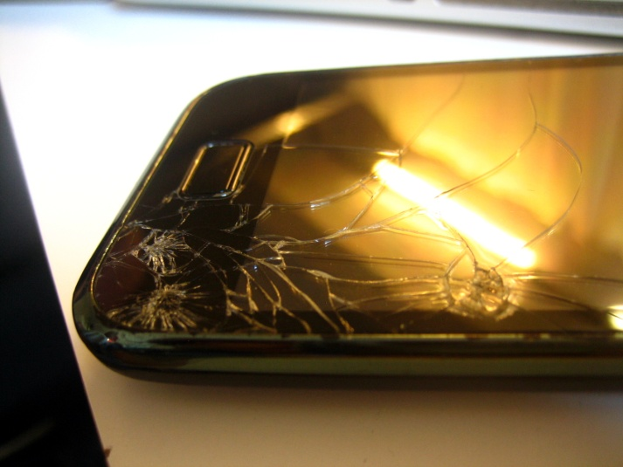
Driving Question: How can properties of matter and geometric design be incorporated in the manufacturing process to make a better smartphone case?

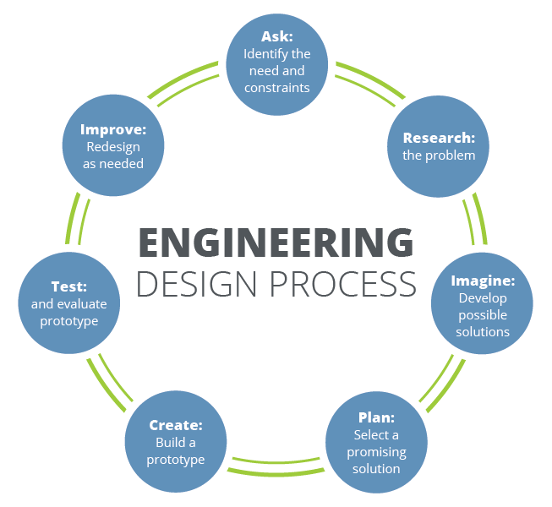

Engineering Design Challenge: Design a better smartphone case considering properties of materials, needs of users with (i.e. weight, strength, etc.), desires of users (preferred design), and cost. Below are the expectations.

Smartphone Case Expectations

Category
Design | The smartphone case is creative and the design fits the needs of the user including being a shape of desired strength.
Lightweight | Weight is not a concern for the user.
Strength | Smartphone case protects model phone after 5+ drop tests from 2 meters.
Cost  Effectiveness | Smartphone case is cost effective.
Material Properties | Team understands how properties affect how we use materials as it is related to materials engineering. Students identified needs and used a creative combination of materials or a specific material to address the needs of the user.

Smartphone Case Project Rubric
Category | 4 | 3 | 2 | 1
Design | The smartphone case design fits all of the needs desires of user. Design was inviting and creative and innovative. | The smartphone case design fits some needs. Design was somewhat creative/innovative. | The smartphone case design fits few of the needs. Little creativity was shown in the design. | The smartphone case design fits one or none of the needs. No creativity was shown.
Lightweight | Weight is not a concern for the user. | Weight becomes a concern of the user long period of time or when carrying lots of other items. | Weight of smartphone case becomes a concern after a short period of time. | Smartphone case weight is not practical.
Strength | Case protects model phone after 5+ drop tests. | Case protects model phone after 3+ drop tests. | Case protects model phone after 1+ drop tests. | Case protects model phone after 0 drop tests.
Cost  Effectiveness | Smartphone case is cost effective. | Smartphone case has a relatively low cost but changes could be made to decrease the cost. | Smartphone case design was expensive for the case created. | No relation was made between materials used and cost. Product is too expensive.
Material Properties—Material Science Engineering | All team members showed a superior understanding of chemical and physical properties and how they influence materials used when creating products. Each  was able to show/explain why chosen materials were ideal for this product when asked throughout the project. | Some team members showed a superior understanding or all showed basic understanding of chemical and physical properties and how they influence the materials used when creating products. One or two were able to demonstrate why chosen materials were ideal for this product when asked throughout project. | One team member showed a superior understanding and some showed basic understanding of chemical and physical properties and how they influence the materials used when creating products. Some were able to demonstrate why chosen materials were ideal for this product. | No member showed a superior of chemical and physical properties and how they influence materials used when creating products. Some were able to show/explain why chosen materials were ideal for this product when asked throughout the project
Engineering Design Process | All team members showed mastery understanding of the engineering design process. | Some team members showed mastery understanding of the engineering design process. | One or two team members showed mastery understanding of the engineering design process. | No team members showed mastery understanding of the engineering design process.

Notebook Questions
Answer as instructed.
- What properties are needed in a useful smartphone case?

- Provide a basic labeled sketch of your team’s smartphone case design.

- Explain what materials you plan to use. Why? Discuss their chemical and physical properties.

- List the materials and their costs as you build your prototype.

- Before testing, weigh your case. Record the mass of your case here. ______________

- Drop Test Results: How many drop tests did your phone survive? Was the case damaged? Was the “phone” damaged? Describe. What changes are you considering?
Scaled Drawing
Team Name___________ Team Members: __________________

____________________________Period _____ Date_________

On this page you will sketch your prototype to scale. (Reminder, this means including proper measurements.) Materials should be labeled on the sketch. Label with colors and create a key.

