Post-Activity Assessment
Data interpretation
Once we have tested our designs, we will place the data into this table. Once the table is complete we will transfer the data to our bar graph below. Make sure you label your title, x-axis, and y-axis. Calculate the change in decibels by subtracting the decibel reading of an empty box from a completed design.

Group name | Decibels read
Before materials:
After materials:
Change in decibels:
Surface Area:
Before materials:
After materials:
Change in decibels:
Surface Area:
Before materials:
After materials:
Change in decibels:
Surface Area:
Before materials:
After materials:
Change in decibels:
Surface Area:
Before materials:
After materials:
Change in decibels:
Surface Area:
Before materials:
After materials:
Change in decibels:
Surface Area:
Before materials:
After materials:
Change in decibels:
Surface Area:

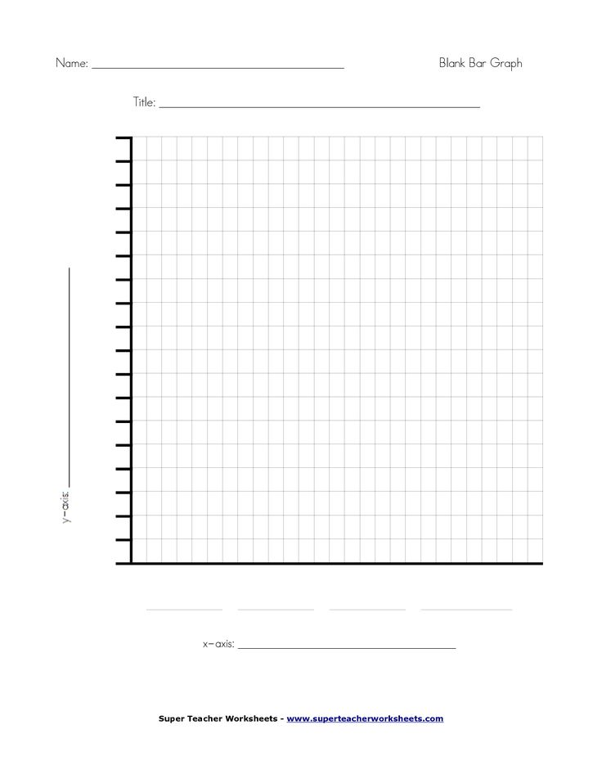

Graphing analysis questions

- Which group had the greatest decibel reading?
____________________________________________________________________________________________________________________________________________________________________________________________________________________________________________________________________________________________________________________________________________________

- Which group had the least decibel reading?
____________________________________________________________________________________________________________________________________________________________________________________________________________________________________________________________________________________________________________________________________________________

3. What is the difference in decibel readings between the greatest and least groups?
____________________________________________________________________________________________________________________________________________________________________________________________________________________________________________________________________________________________________________________________________________________

4. Why do you think the group with the greatest decibel reading received that? (Think about the materials)
____________________________________________________________________________________________________________________________________________________________________________________________________________________________________________________________________________________________________________________________________________________

5. Why do you think the group with the least decibel reading received that? (Think about the materials)
____________________________________________________________________________________________________________________________________________________________________________________________________________________________________________________________________________________________________________________________________________________

Reflection questions
- Based off of the soundproof room challenge, which types of materials absorb sound? Explain using evidence from the information you gained in the soundproof room challenge.
____________________________________________________________________________________________________________________________________________________________________________________________________________________________________________________________________________________________________________________________________________________

- Based off of the soundproof room challenge, which types of materials reflect sound? Explain using evidence from the information you gained in the soundproof room challenge.
____________________________________________________________________________________________________________________________________________________________________________________________________________________________________________________________________________________________________________________________________________________

- If you were to complete this challenge again, what would be something you would change about your soundproof based off of the testing and data completed in this challenge?
____________________________________________________________________________________________________________________________________________________________________________________________________________________________________________________________________________________________________________________________________________________

