Soundproofing Material Handout

Guiding question: Which material absorbs the most amount of sound in a room?

Data interpretation
As we test each group’s material, record the decibel reading. We will create a bar graph (on page 2) based on our results. On your bar graph, you will place the group name for the x-axis and the decibel reading for the y-axis.

Group name | Decibel reading
Fabric: felt, cotton, fleece | Before material: _____  After material:_____  Change in decibel reading: (before *minus* after):______
Wood: Popsicle sticks, toothpicks | Before material: _____  After material: ______  Change in decibel reading: (before *minus* after):______
Styrofoam: packing peanuts, plates, cups | Before material: ________  After material: ______  Change in decibel reading: (before *minus* after):______
Paper: notecards, newspaper, printer paper | Before material: ________  After material: ________  Change in decibel reading: (before *minus* after):______
Metallics: foil | Before material: ________  After material: ________  Change in decibel reading: (before *minus* after):______
Plastics: plastic plates, cups | Before material: ________  After material: ________  Change in decibel reading: (before *minus* after):______

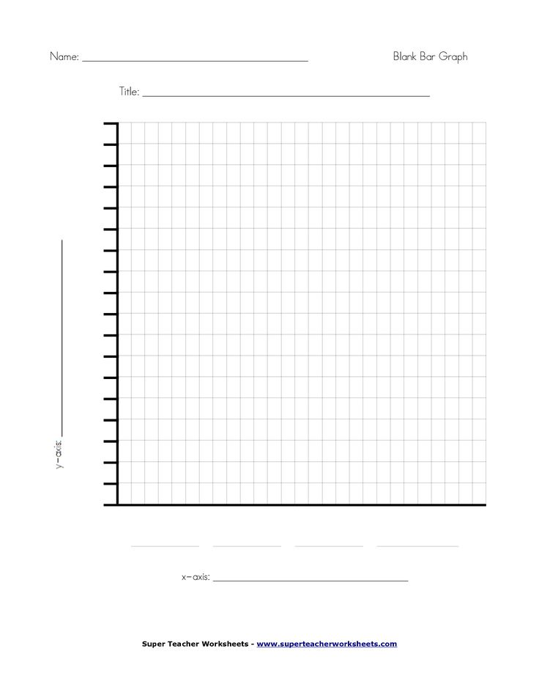

Graphing analysis questions

- Which materials registered the greatest decibel reading?
____________________________________________________________________________________________________________________________________________________________________________________________________________________________________________________________________________________________________________________________________________________

- Which materials registered the least decibel reading?
____________________________________________________________________________________________________________________________________________________________________________________________________________________________________________________________________________________________________________________________________________________

- Describe the type of materials that absorbed the most sound.
____________________________________________________________________________________________________________________________________________________________________________________________________________________________________________________________________________________________________________________________________________________

- Describe the type of materials that did not absorb the most sound.
____________________________________________________________________________________________________________________________________________________________________________________________________________________________________________________________________________________________________________________________________________________

- What is the change of decibels between the greatest reading and the least reading?
____________________________________________________________________________________________________________________________________________________________________________________________________________________________________________________________________________________________________________________________________________________

