Appendix G: Technical Report Template

Day __
Team members: ________________
__________________
__________________
__________________
Refer to Engineering Design Process:
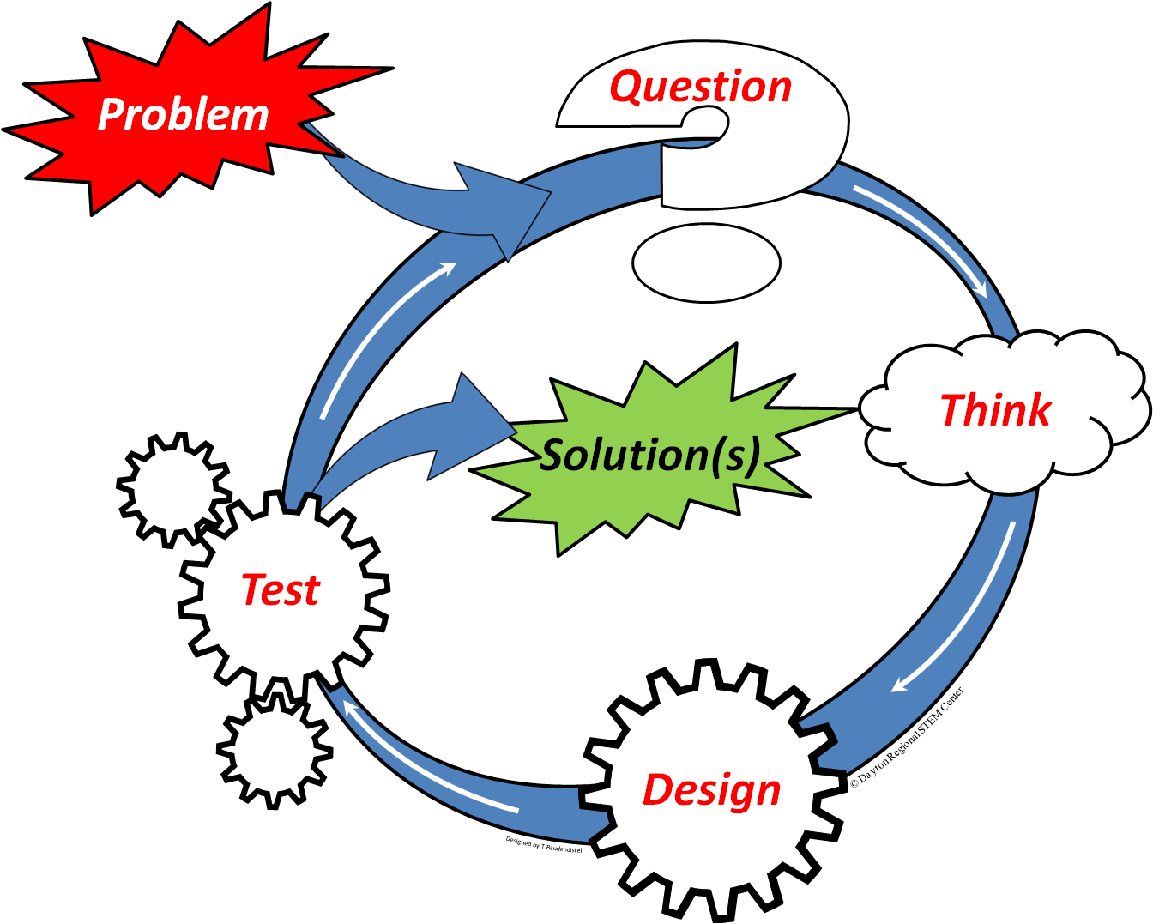
Accomplished tasks:

Problems encountered during engineering design process and how did you solve them:

Immediate future goals:

