Post-Assessment

- What does buoyancy mean? What materials are buoyant?

- What are some ways that boats move?

- One thing I am proud of myself for is:

- One thing I could have done better during this project was:

- One way I helped my group during this project was:

- One challenge that our group faced during this project was:

- Things we could have done differently or improved were:

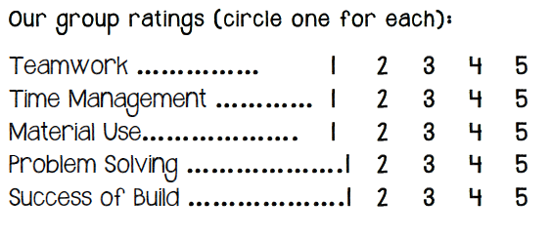

4. One thing I could have done better during this project was:
____________________________________________________
_______________________________________________
_____________________________________________

