Follow-up Analysis Worksheet #5 Answer Key

Essential Questions: How is mathematics connected to the engineering process?

According to Florida Fish and Wildlife Conservation Commission, a bloom of the red tide organism, Karenia Brevis, persists on the Florida Gulf Coast. This type of algae is categorized using different bloom concentrations which are measured in (cells per liter).

Read the chart below created by Mary Harper, FWC/FWRI, of St. Petersburg, Florida.
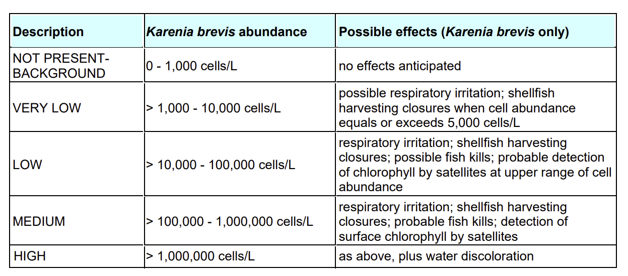

- There are 1,000 cells/L in a river near your house. but at your friend’s Charles house there is 10,000 cells/L. How many times greater is 10,000 than 1,000?

Ⓐ 10,000 is 10 times more than 1,000.
Ⓑ 10,000 is 100 times more than 1,000.
Ⓒ 10,000 is $\frac{1}{10}$of 1,000.
Ⓓ 10,000 is $\frac{1}{100}$of 1,000.

- Jan and Lin decided that they wanted to spend the day at Indian Rocks Beach but there was a significant difference between the number of algae present from the amount at Clearwater Beach. Indian Rocks Beach has 1,000,000 cells/L present and Clearwater Beach has 10,000 cells/L. How many times greater is the algae present at Indian Rocks Beach than at Clearwater Beach?

Ⓐ The algae present at Clearwater Beach is 10 times more than Indian Rocks Beach.
Ⓑ The algae present at Clearwater Beach is 100 times more than Indian Rocks Beach.
Ⓒ The algae present at Clearwater Beach is $\frac{1}{10}$less than Indian Rocks Beach.
Ⓓ The algae present at Clearwater Beach is $\frac{1}{100}$less than Indian Rocks Beach.

Next Page
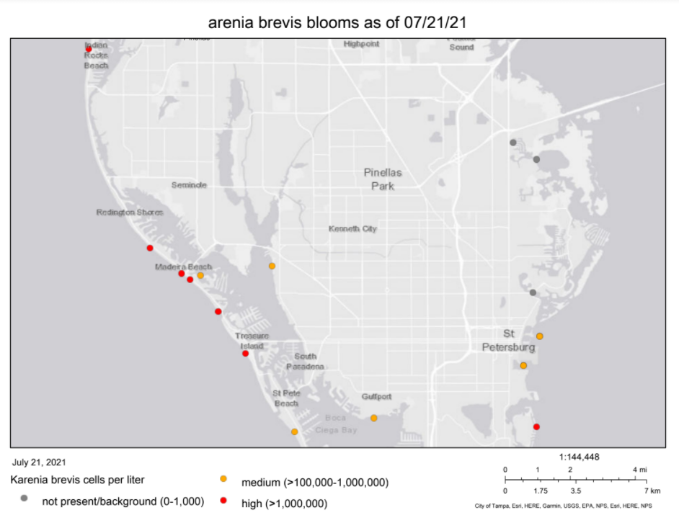

- Using the map above, what is the difference of algae present between Treasure Island and St. Pete Beach? Treasure Island currently has 1,000,000 cells/L whereas St. Pete Beach currently has 100,000 cells/L.

Ⓐ Treasure Island has 10 times more algae present than St. Pete Beach.
Ⓑ Treasure Island has 100 times more algae present than St. Pete Beach.
Ⓒ The algae present at Treasure Island is $\frac{1}{10}$less than St. Pete Beach.
Ⓓ The algae present at Treasure Island is $\frac{1}{100}$less than St. Pete Beach.

- According to the map above, how many areas have 0-1,000 cells per liter present?

Ⓐ One
Ⓑ Two
Ⓒ Three
Ⓓ Four
Ⓔ Five
Ⓕ None of the above

