Engineering Design: Build a Roller Coaster Worksheet
Iteration #1: Use the space below to design your roller coaster. Label the parts of your diagram with a "p", where the potential energy is high. Label parts of the diagram with a "k" where the kinetic energy is high.

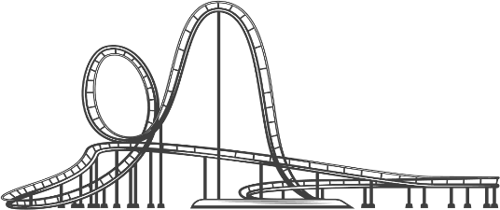
Iteration #1 Reflection
- Were you successful in getting your ball to travel throughout your entire roller coaster unassisted? Why or why not?
_________________________________________________________________________________________________________________________________________________________________________________________________________________________________________________________
_________________________________________________________________________________________________________________________________________________________________________________________________________________________________________________________

- How long did it take your ball to travel through your roller coaster (in seconds)? _____

3. What caused your ball to stop?
_________________________________________________________________________________________________________________________________________________________________________________________________________________________________________________________
_________________________________________________________________________________________________________________________________________________________________________________________________________________________________________________________

Re-design: Iteration #2
Create a second design incorporating things that you would do differently from the first iteration. If your design and build were successful during the first iteration, your challenge would be to incorporate a loop in your design and build this time around.

Iteration #2 Reflection
1. Were you successful in getting your ball to travel throughout your entire roller coaster unassisted? Why or why not? ________________________________________________________________________________________________________________________________________________________________________________________________________________________________________________________________________________________________________________________________________________
________________________________________________________________________________________________________________________________________________________________________

2. How long did it take your ball to travel through your roller coaster (in seconds)? _____

3. What caused your ball to stop? ________________________________________________________________________________________________________________________________________________________________________________________________________________________________________________________________________________________________________________________________________________________________________________________________________________________________________________________________________________________________________________________

