Concrete Composites Lab Worksheet

Pre-Activity Assessment: Characterization of concrete
- Below is the recipe for making cement. Identify if each item is a solid, liquid, or gas. Then, classify if each item as an element, compound, a homogeneous mixture or a heterogeneous mixture.

- Hypothesize whether you think the process of mixing cement, sand, and gravel into Quikrete is a physical or chemical process. Why do you think this?

- Hypothesize whether you think the process of turning cement mix into concrete is a physical or
chemical process. Why do you think this?

Formative Assessment: Properties of concrete
- Listed below are the properties we will be testing for our concrete samples. Identify if the property
is a physical or chemical property by placing it in the T-Chart.
Mass | Wettability
Volume | Luster
Strength | Solubility at Room Temperature
Reactivity with Soap | Reactivity with Oxygen
Density | Texture
Conductivity | Phase at Room Temperature
Reactivity with Acid | Reactivity with Water
Color | Hardness
Shape | Reactivity with Alcohol

- If the property is a Physical Property, identify if the property is quantitative or qualitative and if it is
intensive or extensive by writing the property where it belongs in the Venn diagram below.
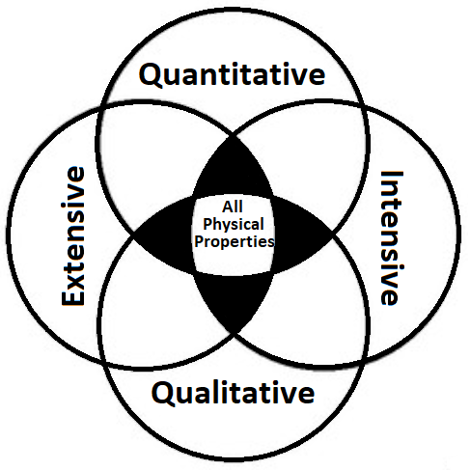
- Explain how you identified if the property was physical or chemical.

Follow the procedures for each station to collect the data for the following properties.
Physical Properties: | Observations:
Color
Shape
Luster
Texture
Phase at Room Temp.
Solubility at Room Temp.
Hardness
 | Measurements:
Wettability (s)
Average Mass (g)
Average Volume (cm)
Average Density (g/cm)
Average strength (lbs)
Chemical Properties: | Observations:
Reactivity with Oxygen
Reactivity with Soap
Reactivity with Water
Reactivity with Alcohol
Reactivity with Bleach (Base)
Reactivity with HCl (Acid)
Solubility at Room Temp.
Hardness

Post-Activity Assessment: Changing Cement
Complete the following sentences.

The hardness test performed was an example of a __________________ change. I know this because __________________________________________________________________________________________________________________________________________________________________________________________________________________________________________________________________________________________________________________________________________________________________________.

The reactivity tests performed were an example of a __________________ change. I know this because __________________________________________________________________________________________________________________________________________________________________________________________________________________________________________________________________________________________________________________________________________________________________________.

Making Sense Assessment: Conclusions
Draw your conclusion based on the graphs created from the whole class data. Compare the results of the
density, wettability, and strength tests on the different composites and identify which performed best for
these properties below.

- Describe the relationship between density and the composite compositions.

- Describe the relationship between wettability and the composite compositions.

- Describe the relationship between strength and the composite compositions.

- In your opinion, which concrete composite performed the best overall? Why do you think this?

- An important part of the engineering process is to improve what has already been done. Based on
which composite you think performed the best, choose one variable you can change to improve it.
Make sure to describe which property you are trying to improve and why your change would result
in a better concrete composite.

