Graphing Data and Statistical Analysis with Excel Practice
Answer Key
Independent Practice: Unemployment: College vs. High School Graduates
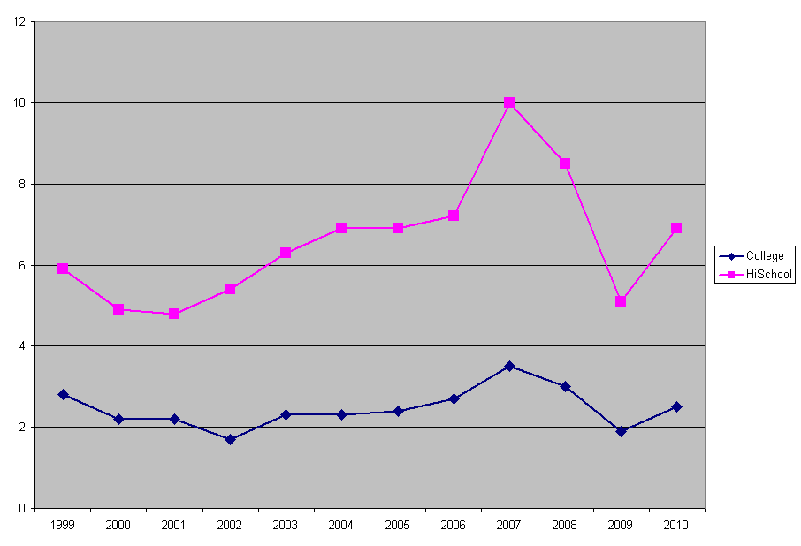
- Creating a graph answer

- Formatting a graph answer
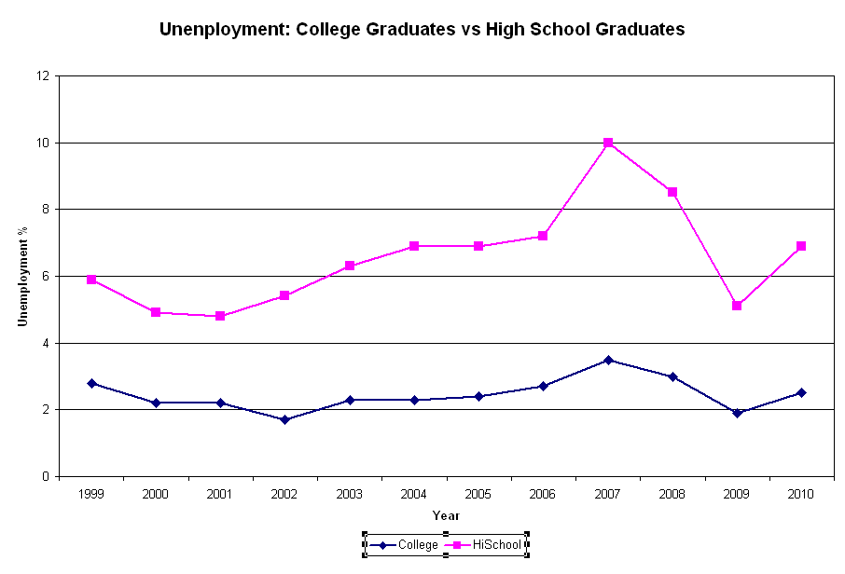

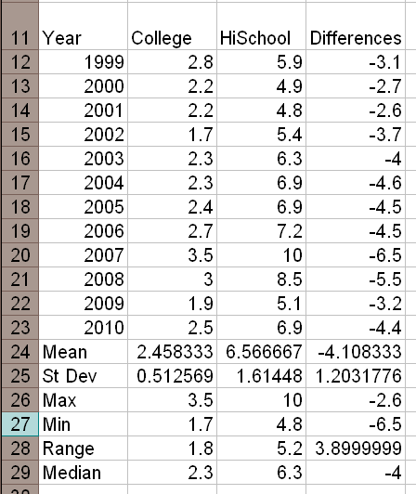

- Calculating statistics answer

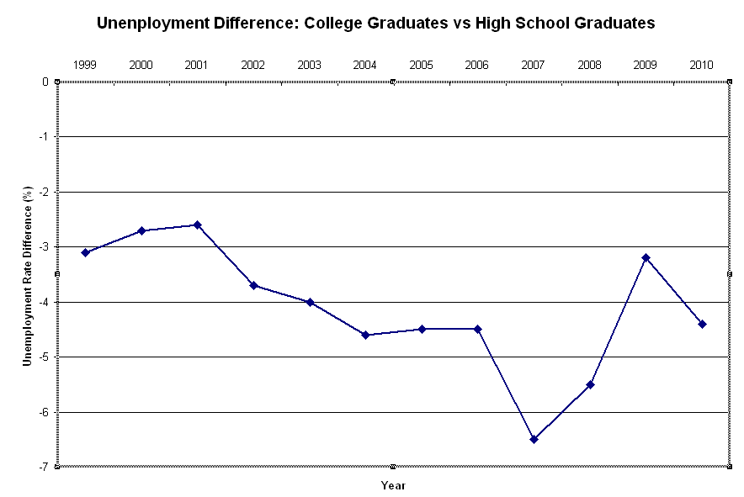
- Graphing data differences answer

- Graphing mean and standard deviation for differences answer
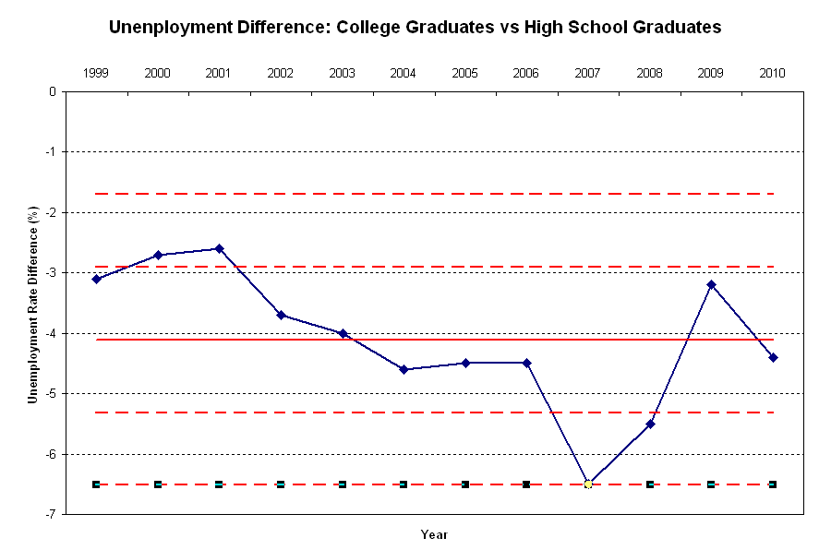

- Compute the sample differences t-value, p-value and sampling standard deviation answers
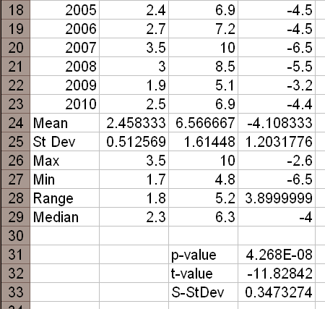

Because p-value = 0.00000004 is less than 0.05 or 0.10 then there is evidence at the 5% or 10% level of significance to reject the original assumption (H₀) that unemployment rates are the same, and conclude that the unemployment rate for the high school graduates is greater than the unemployment rate for college graduates.

Independent Practice: Birth Rates vs. Death Rates
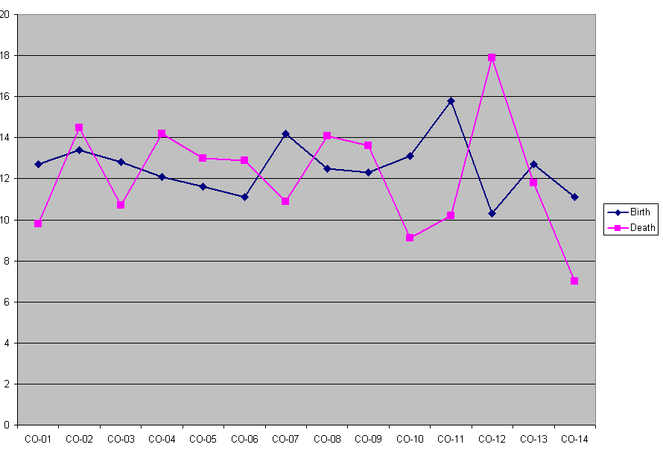
- Creating a graph answer

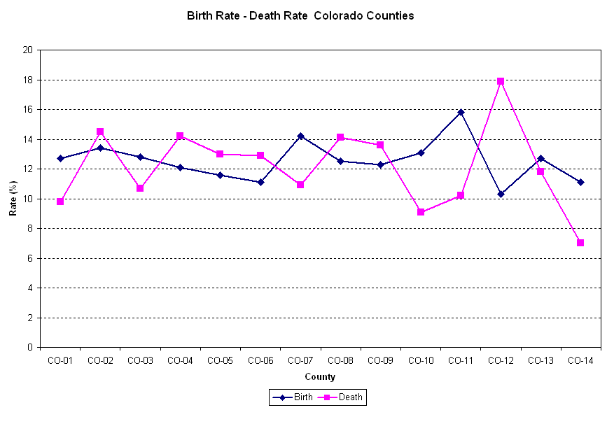
- Formatting a graph answer

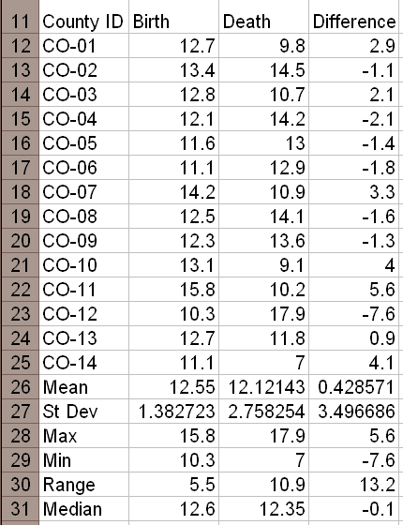
- Calculating statistics answer

- Graphing data differences answer
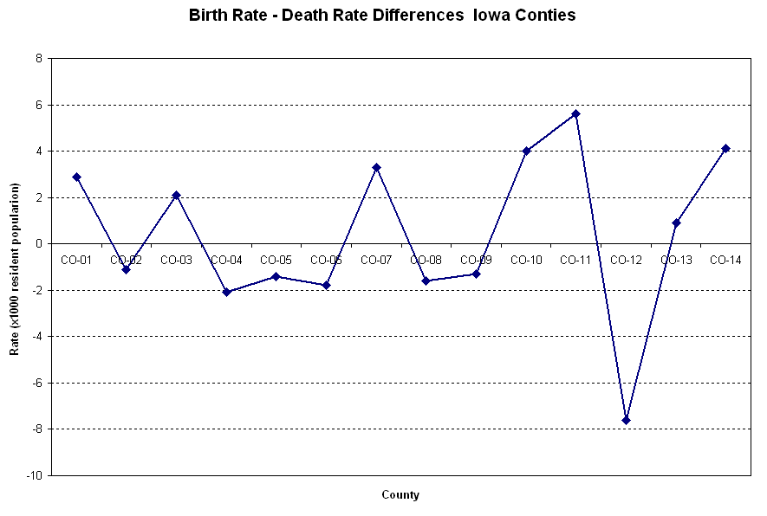

- Graphing mean and standard deviation for differences answer
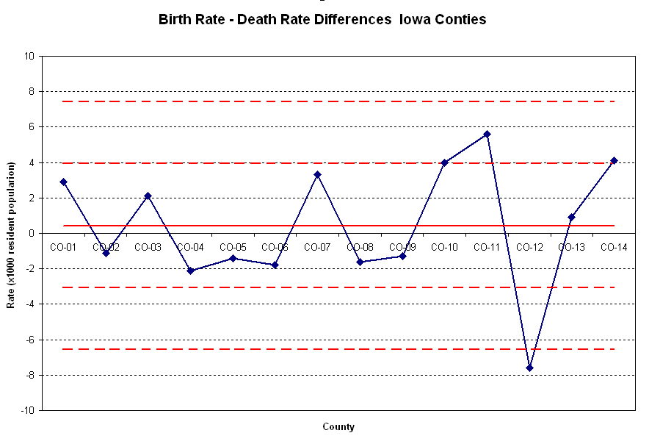

- Compute the sample differences t-value, p-value, and sampling standard deviation answer
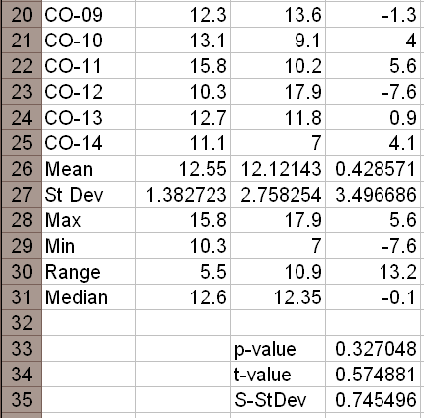

Because p-value = 0.327 is greater than 0.05 or 0.10, no evidence exists at the 5% or 10% level of significance to reject the original assumption (H₀) that there is a statistical significant difference between birth rates and death rates in Ohio counties.

Addendum: Data Set Descriptions and Sources
- Guided Practice: Average Faculty Salaries, Males vs. Females
This paired data of average salaries for assistant professors comes from a random sample of 22 US colleges and universities and compares average salaries (x $1,000/year) for male and female assistant professors. (Source: Academe, Bulletin of the American Association of University Professors)
College ID | Male AP | Female AP
C-1 | 34.5 | 33.9
C-2 | 30.5 | 31.2
C-3 | 35.1 | 35.0
C-4 | 35.7 | 34.2
C-5 | 31.5 | 32.4
C-6 | 34.4 | 34.1
C-7 | 32.1 | 32.7
C-8 | 30.7 | 29.9
C-9 | 33.7 | 31.2
C-10 | 35.3 | 35.5
C-11 | 30.7 | 30.2
C-12 | 34.2 | 34.8
C-13 | 39.6 | 38.7
C-14 | 30.5 | 30.0
C-15 | 33.8 | 33.8
C-16 | 31.7 | 32.4
C-17 | 32.8 | 31.7
C-18 | 38.5 | 38.9
C-19 | 40.5 | 41.2
C-20 | 25.3 | 25.5
C-21 | 28.6 | 28.0
C-22 | 35.8 | 35.1

- Independent Practice: Unemployment: College vs. High School Graduates
This paired data shows the percentage of unemployed high school graduates vs. unemployed college graduates for the years 1998-2010. (Source: Statistical Abstract of the U.S.)
Year | College | High School
1999 | 2.8 | 5.9
2000 | 2.2 | 4.9
2001 | 2.2 | 4.8
2002 | 1.7 | 5.4
2003 | 2.3 | 6.3
2004 | 2.3 | 6.9
2005 | 2.4 | 6.9
2006 | 2.7 | 7.2
2007 | 3.5 | 10.0
2008 | 3 | 8.5
2009 | 1.9 | 5.1
2010 | 2.5 | 6.9

- Independent Practice: Birth Rates vs. Death Rates
This paired random sample from 22 Ohio counties shows the rates per 1,000 inhabitants.
(Source: County and City Data Book, 12th edition, U.S. Dept. of Commerce)
County ID | Birth | Death
CO-01 | 12.7 | 9.8
CO-02 | 13.4 | 14.5
CO-03 | 12.8 | 10.7
CO-04 | 12.1 | 14.2
CO-05 | 11.6 | 13.0
CO-06 | 11.1 | 12.9
CO-07 | 14.2 | 10.9
CO-08 | 12.5 | 14.1
CO-09 | 12.3 | 13.6
CO-10 | 13.1 | 9.1
CO-11 | 15.8 | 10.2
CO-12 | 10.3 | 17.9
CO-13 | 12.7 | 11.8
CO-14 | 11.1 | 7.0

