**GeoGebra Basics Practice**

**Spheres Student Independent Practice**

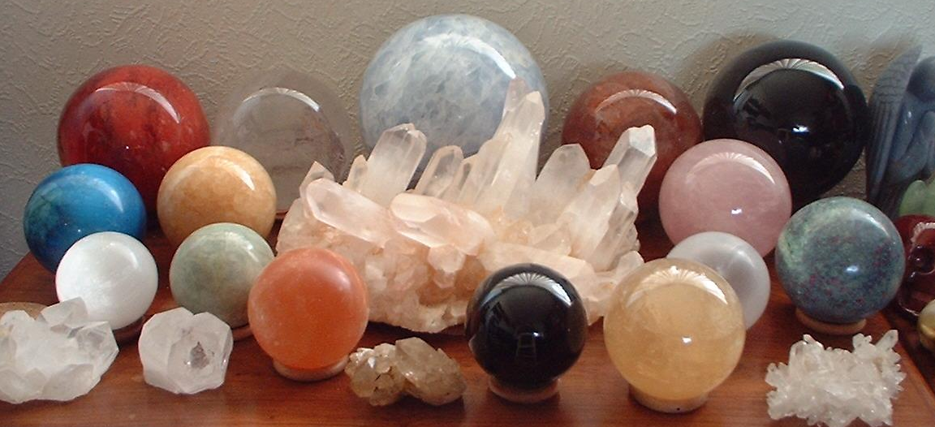

**1**

**4**

**2**

**7**

**9**

**10**

**11**

**3**

**5**

**6**

**8**

**12**

**13**

**Figure 1.**

**Set Up a Work Session**

1. Open a new GeoGebra session. Use the full screen window.
2. In *Graphing View*, insertthe picture file, MarbleSpheres.jpg, which is the same image as Figure 1.
3. Place the lower left image corner at the origin, and the lower right corner at (10.64, 0).
4. Set the image as the background.

**Exercises**

1. Estimate the on-screen radius for sphere 13. What is this value?
2. If the real diameter of sphere 13 is 5.62 cm, estimate the real radius of sphere 1.
3. Estimate the radius of sphere 7.
4. Estimate the radius of sphere 10.
5. Estimate the radius of sphere 8.
6. Estimate the radius of sphere 3. Do you see any problem in this estimation?
7. What are the coordinates of the center of sphere 7? Draw a point with these coordinates.
8. What are the coordinates of the center of sphere 10? Draw a point with these coordinates.
9. Measure the on-screen distance between centers obtained in exercises 7 and 8. What is this value?   
   Estimate the real distance between these two spheres. What is this value?
10. Is the distance estimated in exercise 9 reasonable? Why or why not?
11. What are the coordinates of the center of sphere 1? Draw a point with these coordinates.
12. What are the coordinates of the center of sphere 8? Draw a point with these coordinates.
13. Measure the on-screen distance between centers obtained in exercises 11 and 12. What is this value? Estimate the real distance between these two spheres. What is this value?
14. Is this estimated distance reasonable? Why?

**Rapa Nui Student Independent Practice**

**Set Up a Work Session**

1. Open a new GeoGebra session. Use a full screen window.
2. In the *Graphing View*, insertthe picture file, EasterIsland.jpg.
3. Place the lower left image corner at the origin, and the lower right corner at (11, 0).
4. Set the image as the background.

**Background Information**

Rapa Nui, also known as Easter Island (the name given by Europeans), is located in the southeast Pacific Ocean and is famous for its ~1,000 carvings of moai—massive human-faced statues. On average, the statues stand 4 meters high and weigh 12.5 metric tons; they are human heads-on-torsos carved in the male form from rough, hardened volcanic ash. The highest erected statue is 10 m long and weighs 74 tons, although one unfinished moai in the Ranu-Raraku quarry is 21 m long and weighs 180 tons.

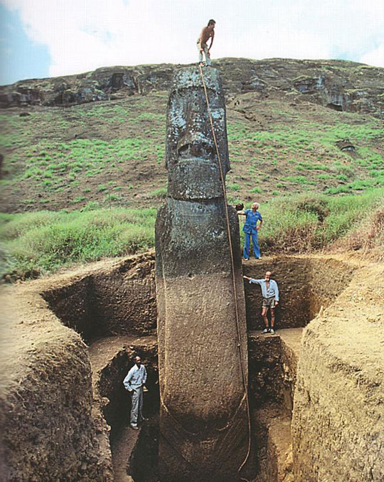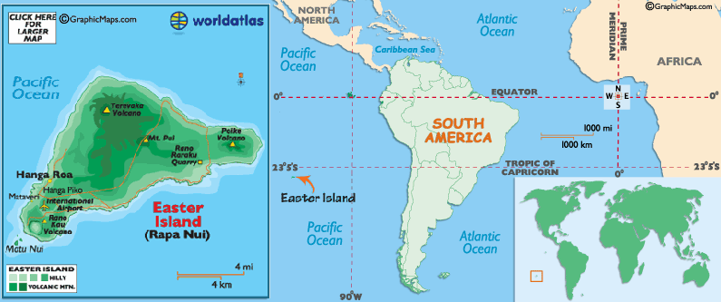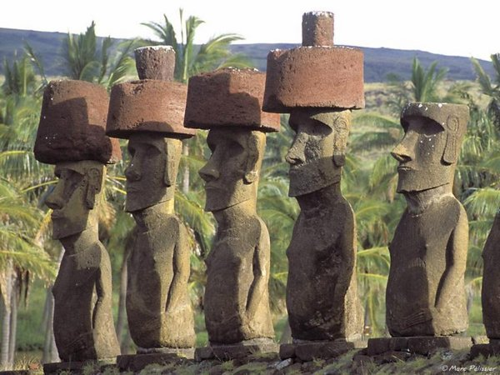

**Statistics on Easter Island's Moais**

* To date, a total of 887 monolithic statues have been located on Easter Island.
* 397 are still *in situ* in quarries at the Rano Raraku central production center.
* 288 full statues (32% of 887) were successfully transported to a variety of image ahu locations.
* 92 are *in transport;* 47 of these lie in various positions on prepared roads or tracks outside the Rano Raraku zone.

Many questions persist: For whom and for what purpose were the moais built? Why was their construction suddenly abandoned? In this short practice, you will use Geogebra to estimate some distances on Easter Island.

**Exercises**

1. Find the on-screen distance between volcano Terevaka and volcano Puakatike.
2. Using the scale in the map, estimate the real distance between volcano Terevaka and volcano Puakatike.
3. Estimate the distance between Volcano Ranu Raraku and the Image ahu Vai Mata.
4. Estimate the distance between the Image ahu A Tanga and Hanga Te’e.
5. What is the distance between ahu *Te Hata Hero to* the Ranu Raraku Volcano?
6. What is the distance between the most separated points of Easter Island?
7. **Advanced Question**. It is assumed that the moais were transported to the ahu sites along the shores. Estimate the *along-shore* distance covered from Ranu Raraku Quarry to Vinapu.   
   (Hint: Explore Polyline option in Tool bar.)
8. **Advanced Question**. Estimate the area of the Easter Island.   
   (Hint: Explore the Line and Angle Toolbar menus.)