Testing Equipment Setup Visual Aid
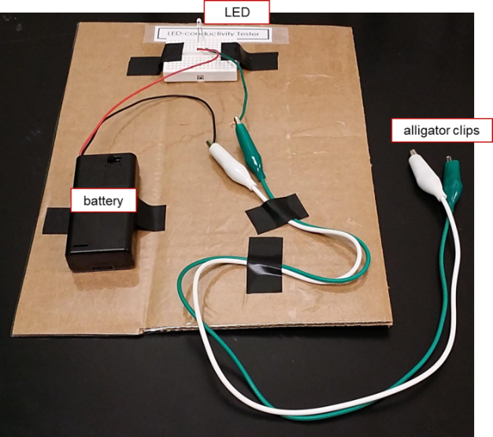
Setup for homemade LED-conductivity tester

Example materials to purchase (if you do not have similar items in your classroom/lab supply):
battery holder (for 2 AA batteries): such as these five 2AA cell battery 3V clip holder box case with switch for $4.36 at http://www.ebay.com/itm/New-5-Pcs-2-AA-Cells-Battery-3V-Clip-Holder-Box-Case-with-Switch-Black-/181003986908?pt=LH_DefaultDomain_0&hash=item2a24ada7dc
electronic breadboard: such as these five mini solderless prototype breadboards with 170 tie points for $15.91 at http://www.dhgate.com/5pcs-mini-solderless-prototype-breadboard/p-ff8080813d1f5115013d342aafd06dda.html or www.ebay.com or www.amazon.com
LED light: such as this pack of 5 LED semiconductors (item# CP33693-00) for $6.20 at https://sargentwelch.com/store/catalog/product.jsp?catalog_number=CP33693-10
wire: such as this 18 gauge copper wire at http://www.ebay.com/itm/25ft-200-Ft-18-Gauge-BLUE-RED-Yellow-Black-8-COLORS-Primary-Wire-CABLE/271067773743?_trksid=p2047675.c100005.m1851&_trkparms=aid%3D222007%26algo%3DSIC.MBE%26ao%3D1%26asc%3D24895%26meid%3D8991313873457682189%26pid%3D100005%26prg%3D10500%26rk%3D1%26rkt%3D6%26sd%3D271206667004&rt=nc
alligator clips: such as this 20-inch double ended crocodile clip alligator test jumper probe lead wire for $2.29 at http://www.ebay.com/itm/20-Double-ended-Crocodile-Clip-Alligator-Test-Jumper-Probe-Lead-Wire-/181222296525?pt=LH_DefaultDomain_0&hash=item2a31b0cbcd
Setup for electrical conductivity tester
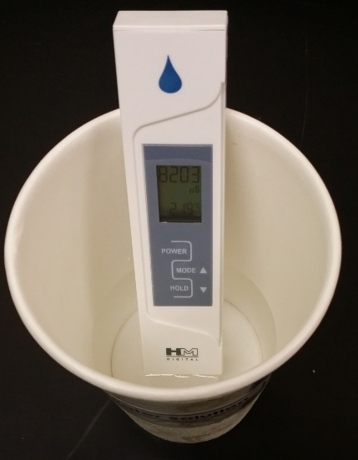

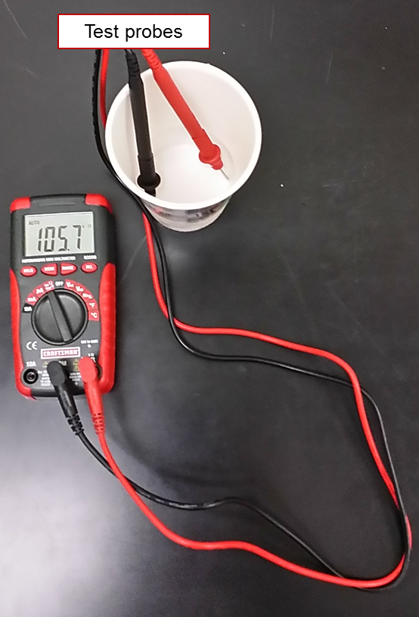
Setup for resistance measurements using digital multimeter

