**Magic Magnetic Fluid Activity –   
Liquid Magnets Worksheet – Answers**

**C:\Users\yowell\AppData\Local\Microsoft\Windows\Temporary Internet Files\Content.IE5\2ZBOBS2T\MC900340404[1].wmfPart 1: Concepts**

1. How can a Liquid be magnetic?

Ferromagnetic particles dispersed in liquid to form a colloid OR

Paramagnetic salt liquids

1. What type of magnetic material (paramagnetic, diamagnetic, or ferromagnetic) would be best for making a liquid magnet? Explain the fundamental differences between the three classifications of magnets and why you would use one over the other.

A ferromagnetic material because of the large magnetic permeability and spontaneous alignment of domains when subjected to external magnetic field.

Diamagnetic: when exposed to external magnetic field an induced dipole moment opposes the external magnetic field lowering the net magnetic field.

Paramagnetic: Permanent dipole moments align with external magnetic field but are opposed by thermal agitations reducing the attraction.

Ferromagnetic: Spontaneous alignment of magnetic moment of each atom forming domains which are randomly oriented when in an unmagnetized state.

1. The picture below depicts what is going on in your test tube. Although you cannot see the particles, they are there. Fill in the three spaces in the magnified picture. Below the picture write the purpose of each labeled component.

Surfactant

Carrier Fluid

Magnetic Particle,  
or Toner

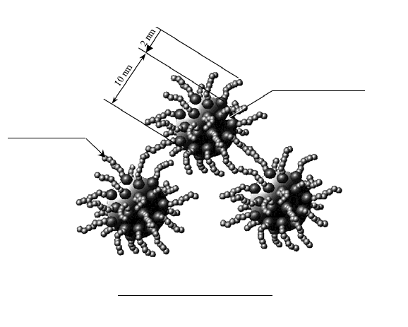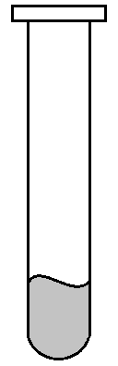

Component 1:

*Carrier Fluid:* What transports magnetic nanoparticles when not induced by a magnetic field.

Component 2:

*Magnetic Particle:* What provides the magnetic attraction when exposed to an external magnetic field?

Component 3:

*Surfactant:* Chemical that helps spread magnetic particles apart and attach to carrier liquid.

**Part 2**

1. In the boxes below, draw your observations of the ferrofluid when exposed to the external magnet and when not exposed.

*Drawings will vary.*

1. How would you describe the ferrofluid when it is NOT exposed to an external magnet?

The fluid should be liquid like and free flowing. Most observations show a “blob” of liquid with no definite shape from a top view.

1. How would you describe the ferrofluid when it is exposed to an external magnet? Explain how the physical properties of the fluid changed.

The “blob” of liquid forms a dome shape (side view) with or without spikes (depending on MICR toner and magnet strength). Liquid viscosity is greatly increased and does not free flow. Typical observations and drawings consist of a dome shape mass with a characteristic height with or without spikes.

1. In the space provided below draw the magnetic domains associated with nanoparticles. Compare this behavior to traditional magnetic materials.



Traditional Bulk Magnetic Material: Figure shows a gradual alignment of domains with direction of magnet as a magnetic field is applied in two dimensions. Three dimensional alignments of domains occur in real materials. KEY: bulk material (polycrystalline) will have numerous domains as indicated above.

http://what-when-how.com/nanoscience-and-nanotechnology/magnetic-nanoparticles-in-fluid-suspension-ferrofluid-applications-part-1-nanotechnology/

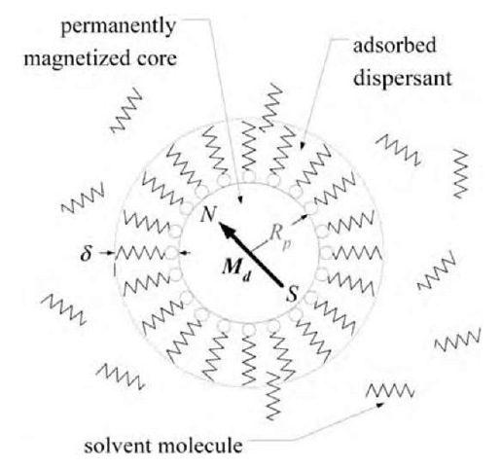

Individual nanoparticles align with magnetic field. Result is a three dimensional depiction of magnetic field directions and varying strengths. KEY: Single domain arrow is characteristic of the nanoparticle because of the particle size can only contain one domain.

1. Why do ferrofluid materials behave differently than bulk magnetic materials?

Ferromagnetic particles within the fluid specifically align with the external magnetic fluid making a dome shape with or without spikes. The spikes are a result of the strong magnetic lines in that particular direction and are present when nanoparticles are strong ferromagnetic particles and the external field is large enough. The liquid carrier fluid allows for shape changes to occur easily under various external magnetic fields.

Bulk magnetic materials are solid, rigid structures that do not change shape under external magnetic fields.

1. Where might you use this type of technology or property manipulation? Name 3 applications with a 1-2 sentence explanation.

Drug Delivery systems: Targeted delivery by developing magnetic drug compatible with human systems where delivery path is guided by a controlled magnetic field.

Magnetic tracking beacon: Inject fluids where a magnetic signature could be detected under an applied magnetic field.

Cooling systems: utilize convection cooling from liquid to achieve higher heat transfer in electronic systems.

*This question is intended to stimulate out-of-box thinking.*