Extension: Learning More About Metastasis and ECM Rigidity
Read “Tension on gut muscles induces cell invasion in zebrafish intestine, mimicking cancer metastasis”
article. Then answer the following questions:

- What changes occur to breast cancer cells when grown on 3-D gels of increasing rigidity?

- How are the epithelial cells of the zebrafish able to invade the surrounding tissue?

- What is meant by an invasive cancer?

- How is this related to human cancer?

- Use the diagram below and based on what you have learned in this lesson, explain why breast and lung cancer are more likely to metastasis then bone cancer?
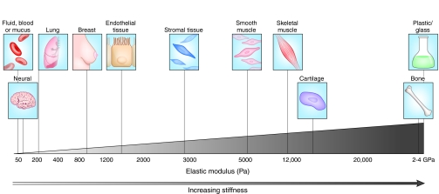
Cox, Thomas & Erler, Janine. (2011). Remodeling and homeostasis of the extracellular matrix: implications for fibrotic diseases and cancer.. Disease models & mechanisms. 4. 165-78. 10.1242/dmm.004077

- The data pictured below show the mutations found in various cancers, which are also varying in tissue stiffness. If the stiffness increases across the x-axis (the top here) from softer to stiffer tissues, what can you conclude about the relationship between mutation rate and tumor stiffness?

Constricted cell migration causes nuclear lamina damage, DNA breaks, and squeeze-out of repair factors

Jerome Irianto, Charlotte R. Pfeifer, Yuntao Xia, Avathamsa Athirasala, Irena L. Ivanovska, Roger A. Greenberg, Dennis E. Discher
doi: https://doi.org/10.1101/035626

