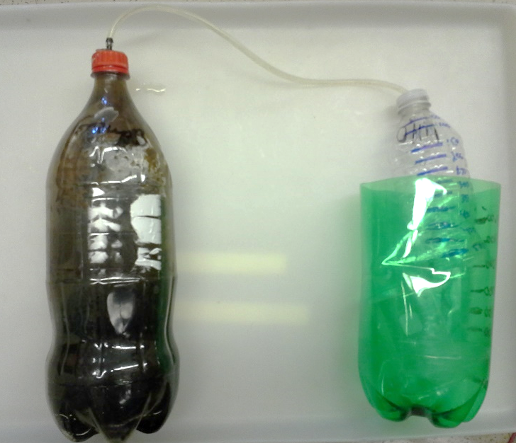
Anaerobic Digestion Data Sheet
Microbe Source:

Start Date:

Height Measurements
Observations/Notes:

Day # | Blank  Biogas Volume | Chopped Hotdog  Biogas Volume | Whole Hotdog Biogas Volume
1
2
3
4
5
6
7
8
9
10

Day # | Blank Sample Height | Unground Sample Height | Ground Sample Height
11
12
13
14
15
16
17
18
19
20
Observation/Notes:

