Dome It Challenge Worksheet
Your scenario: ____________________________

Introduction
- What is the background story of your scenario?
Why are you there? How did you get there?

- What are some limitations of your scenario or what aspects make it difficult to survive?

Solution
- How did you get your energy using biorecycling?

- How did you get your food using biorecycling?

- How did you deal with your waste?

- Draw a sustainable (circular) connection you made as part of your solution.
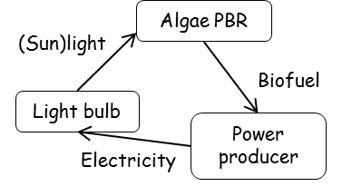
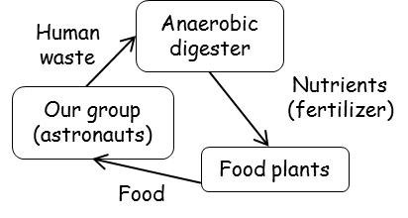

- Do you think you will survive your scenario? Why or why not?

