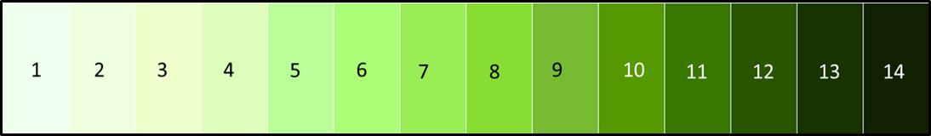
The Great Algae Race Data Sheet

Color Measurements
Day # | Control | Aerated Bottle | Capped Bottle
1
2
3
4
5
6
7
8
9
10
11
12
13
14
15
16

