Engineering Polymers from Potatoes Lab Packet

Objectives:
- Create and test the properties of a polymer made from the starch of potatoes.
- Compare and contrast the effects of using Propan-1,2,3-triol (Glycerol or Glycerin) on the polymer.
- Engineer a polymer that will improve human life.

Pre-Lab /Discussion
Use the information we have talked about and the Engineering Polymers from Potatoes Structure Image Guide (see page 5 in this packet) to answer the following questions:

- Explain/describe what a polymer is.

- What characteristics make starch a polymer? How is it held together?

- Identify the amylopectin and amylose sections of the starch molecule. How are they different?

- Describe how the propan-1,2,3-triol connect to the starch molecule?

Procedure Review:

- Read through the procedure and list all materials you will need (glassware, compounds or solutions, etc.) and safety precautions you will need to follow:

- List any words you do not know or recognize:

Engineering Polymers from Potatoes Procedure

Part 1. Extracting Starch (20 min)
- Clean the potato; grate about 100 g of potato. (Does not have to be peeled)
- Put peeled potato into food processor and add about 100 mL of distilled water. Grind the potato.
- Pour the liquid off through cheesecloth or a strainer into the beaker, leaving the potato behind. Put the leftover potato back into processor, add another 100 mL of water, grind, pour liquid through cheesecloth, into same beaker.
- Allow 5 minutes for the mixture to settle in the beaker.
- Decant the water from the beaker, leaving behind the white starch which should have settled in the bottom. Add about 100 mL distilled water to the starch and stir gently.
- Leave to settle again and then decant the water, leaving the starch behind.
Now you have your starch to make the plastic.

Part 2. Making the Plastic (20 min)
- Put 25 mL of water into a 50 mL beaker and add 2.5 g potato starch, 3 mL hydrochloric acid and 2 mL propan-1,2,3-triol (glycerol).
- Put the watch glass on the beaker and heat mixture using the hotplate. Bring it carefully to a boil and boil gently for 15 minutes. *Make sure to not boil the solution dry, stop heating if it looks like it might.
- Dip the glass rod into the mixture and dot it onto the indicator paper to measure the pH. Add sodium hydroxide slowly, testing after each addition until the mixture is neutral (about 3 mL).
- Pour the mixture into a labeled petri dish and rotate the petri dish to get an even covering.
- Label your mixture and leave it to dry out.
- Repeat steps 7-12 but without the (glycerol) propan-1,2,3-triol.

Part 3. Testing the Plastics
Record all data on the Engineering Polymers from Potatoes Results Sheet below on page 4.

Quantitative Testing:

Density:
- Cut a piece of your plastic about 2cm x 2cm. Find the mass of that piece.
- Using a graduated cylinder filled with a known volume of water find the volume of displacement for that piece of plastic.
- Calculate the density (d = m/v).
- Repeat twice with different pieces of plastic, calculate the average density.

Melting Point:
- Take a 2g sample of your polymer on a watch glass on a hotplate.
- Turn the hot plate to 5.
- Observe and as soon as you see the polymer begin to melt, turn off the hot plate, place a thermometer on the sample (not the hot plate) and measure its temperature.
Qualitative Testing:

Test no. | Action
1. | Look at the sample. Is it transparent, translucent or opaque?
2. | Feel the sample. Does it bend easily? Can it be scratched? What does the surface feel like (rough/smooth)?
3. | Cut the sample with a sharp knife. Does it cut easily? Are the edges smooth or jagged? Does it crumble or flake?
4. | Subject the sample to a float test. Does it float or sink? (Note: not applicable to expanded foam materials. Water should be around room temperature).
5. | Try to burn a small piece of the sample. What is the size and color of the flame? Do molten drips fall from the sample and continue to burn? Does the sample self-extinguish? Is there any odor when the flame has been extinguished?
Identify which material your polymer most closely resembles:
Material | Test no. | Observation
Low density  polyethylene  (LDPE) | 1 | Transparent only as thin film, translucent in thicker sections
 | 2 | Fairly flexible; soft, 'waxy' feel, easily scratched
 | 3 | Easily and smoothly cut
 | 4 | Floats
 | 5 | Not self-extinguishing; molten droplets which usually go out on reaching bench or floor; blue flame with yellow tip and little smoke, smell of burning candle/paraffin when flame is extinguished
High density  polyethylene  (HDPE) | 1 | Transparent only as thin film, translucent in thicker sections
 | 2 | Fairly stiff and hard, can be scratched by fingernail
 | 3 | Easily cut with smooth edges
 | 4 | Floats
 | 5 | Not self-extinguishing; molten droplets which usually go out on reaching bench or floor; blue flame with yellow tip and little smoke, smell of burning candle/paraffin when the flame is extinguished
Polypropylene  (PP) | 1 | Transparent only as thin film, translucent in thicker sections
 | 2 | Stiff; hard, can be scratched by fingernail
 | 3 | Easily cut, fairly smooth edges, when cut with chisel leaves white mark
 | 4 | Floats
 | 5 | Not self-extinguishing; molten droplets which usually go out on reaching bench or floor; flame mainly yellow with a trace of clear blue at the bottom; smell of burning candle/diesel when flame is extinguished.
Polyvinyl Chloride, Unplasticized  (uPVC) | 1 | Transparent (unless fillers or pigments have been added)
 | 2 | Stiff; hard
 | 3 | Fairly easy to cut, smooth edges
 | 4 | Sinks
 | 5 | Burns with difficulty, self-extinguishing; yellow flame, blue-green at bottom edges; unpleasant, acrid odor of hydrochloric acid.
Engineering Polymers from Potatoes Results Sheet

Use this page with Part 3: Testing the plastic from pages 2-3 to record you results and observations. Be as descriptive as necessary.

RESULTS/OBSERVATIONS:
Property | With Glycerol | Without Glycerol
Density
Melting Point
Transparency
Texture
Durability
Float Test
Burn Test
Electrical Conductivity
Thermal Conductivity
In Salt Solution
In Acetone

Other notes and observations:

Engineering Polymers from Potatoes Structural Image Guide
STARCH

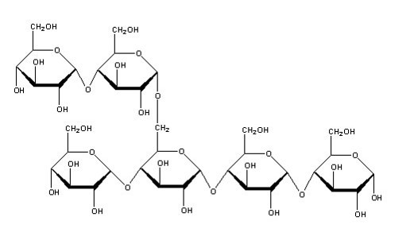

AMYLOSE VS AMYLOPECTIN

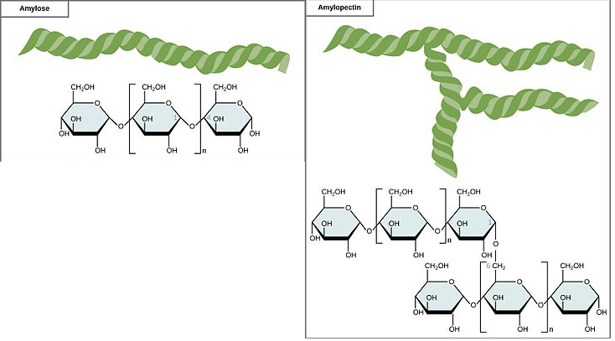

PROPAN-1,2,3-TRIOL (GLYCEROL OR GLYCERIN)

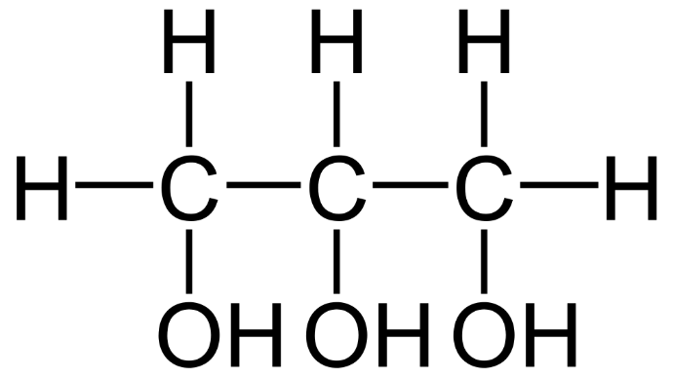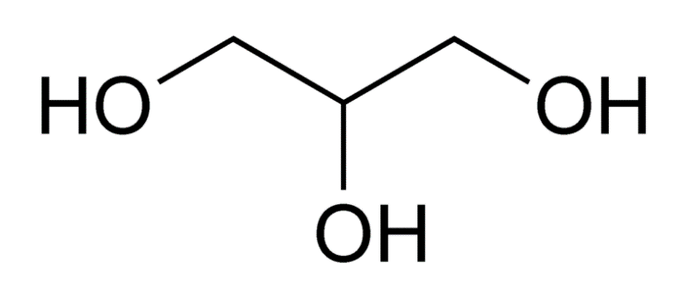

STARCH + GLYCEROL

