Group Leader Discussion Sheet
Instructions: Have your group read a case study about a girl who used the steps of the engineering design process to solve a problem at her school. At each stop, lead your group in discussing what they just read. Use this sheet to guide your discussions, while also letting your group members to ask their own questions if they want clarification.
Everyday Engineering: Using the Engineering Design Cycle to Organize a Locker
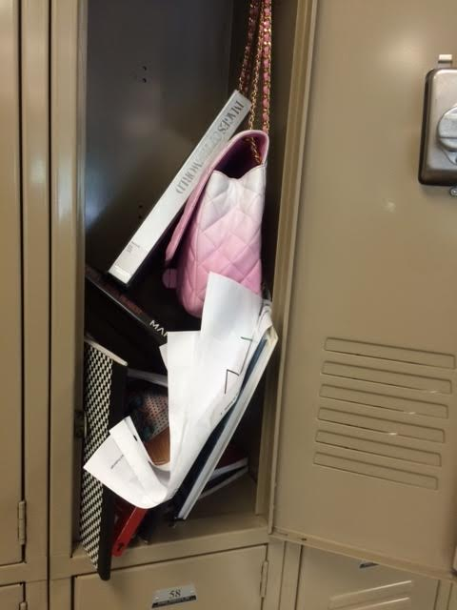
Questions for Stop 1
Ask members of your group to read to Stop 1; then ask them:
- What stage of the engineering design process did Marisol just engage in? Please explain your answer.
- If you were Marisol and you wanted to develop a solution to this problem, what would your next steps be? Please explain.
Questions for Stop 2
Ask members of your group to read to Stop 2; then ask them:
- How did your recommended next steps compare to what Marisol did?
- What stages of the engineering design process did Marisol just engage in? Please explain.
- What are the criteria, or positive features, that Marisol’s design must meet?
- What are the constraints that limit Marisol’s design?
- Based on your school’s lockers, if you were to make a locker organizer of your own, what criteria and constraints would apply to your project?
Questions for Stop 3
Please ask members of your group to read to Stop 3; then ask them:
- How did your recommended next steps compare to what Marisol actually did?
- What stages of the engineering design process did Marisol just engage in? Please explain.
- Marisol and her mother decided to use a cloth organizer and a shelf in order to organize Marisol’s locker. Do you agree with their idea or do you have any better ideas that would meet the criteria and constraints? Please explain your answer.
- The engineering design process often includes testing ideas. If you were Marisol, how would you test your ideas for a cloth organizer and shelf?
- Brainstorm some organizer ideas and share them with the group. Try to make a table similar to the ones Marisol and her mother designed that describes the characteristics of each of the materials you could use to build a locker organizer.
Questions for Stop 4
Ask members of your group to read to Stop 4; then ask them:
- How did your recommendations for testing compare to what Marisol actually did?
- What stages of the engineering design process did Marisol just engage in? Please explain.
- The engineering design process often includes optimizing, or evaluating and improving ideas for the design. If you were Marisol, what would you do to improve the shelf and the cloth organizer?
Questions for Stop 5
Ask members of your group to read to Stop 5; then ask them:
- How did your recommendations for improving the shelf and the cloth organizer compare to what Marisol actually did?
- What stages of the engineering design process did Marisol just engage in? Please explain.
- As a “junior engineer,” what advice would you give to Marisol in order to make her problem solving processes better? What praise would you give to Marisol?
- Do you have any other comments or remaining questions about this case study?
- After reading this case study, what ideas do you have for using engineering design processes to improve other problems at your school or in your community?

