Assembling the Sensor Handout

Let’s get started constructing the Sharp GP2Y0A02YK0F “radar” system:
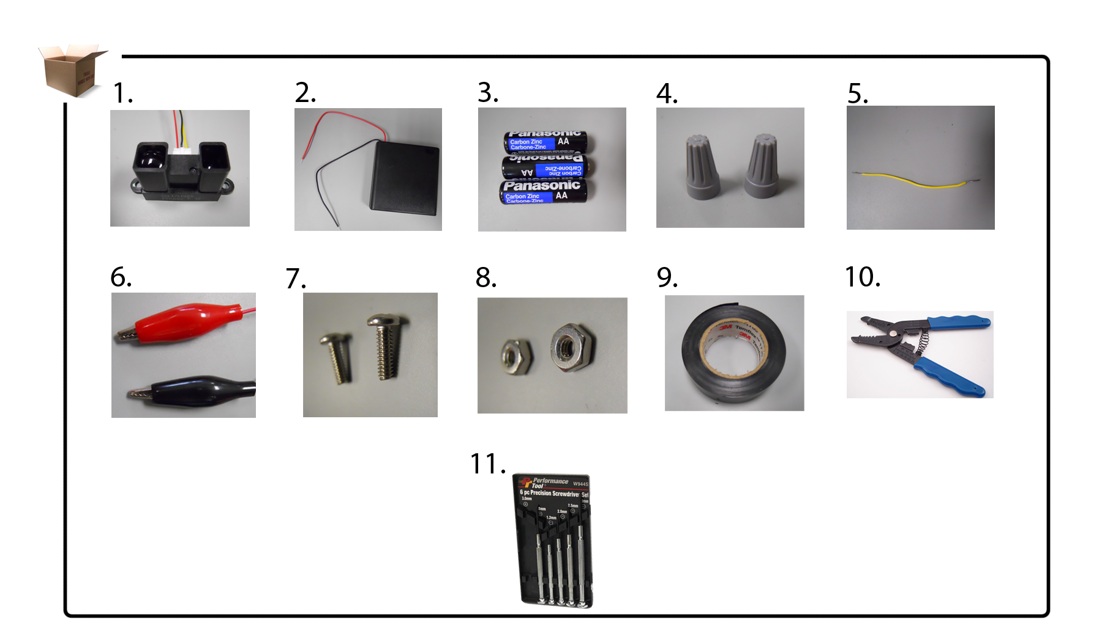

1. Sharp GP2Y0A02YK0F sensor | 2. four AA battery holder with cover  & switch | 3. three AA alkaline batteries | 4. wire-connectors | 5. 18 AWG  2” shield wire
6. alligator clips | 7. #40 x ¾” machine  screw | 8. #40 x ¾” (SAE)  hex nut | 9. electrical  tape | 10. class-shared wire stripper
 |  | 11. precision screwdriver  set | Also: class-shared drill with a 9/64  drill bit | Also: class-shared  Phillips screwdriver

- Pre-Mark and Drill
  - Open the four AA battery holder using a Philips screwdriver.
  - Pre-mark the holder lid on the outside with two holes using a 9/64 drill bit about 37 mm apart. The holes should be directly above battery slot #1.
  - Verify that the battery holder does not contain batteries.
  - Identify the lower part of the four AA battery holder (not the lid).
  - Mark and drill into the side of slot #1 of the battery holder.
    - Pre-mark the outside lower part of the holder in the middle. Drill the hole using the same bit.
  - Mark and drill inside your holder (adjacent to the positive terminal of slot#1). This allows the holder’s VCC and ground wires to enter into slot #1.
    - Pre-mark the edge of the holder above VCC and ground wire opening with a 4 mm diameter. Drill the hole.
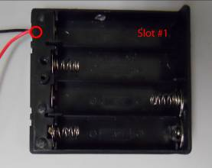
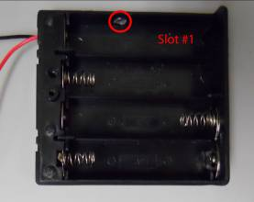
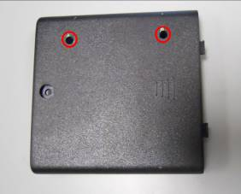

1b 1e 1f
- Sensor Stabilization
  - Align the drilled holes on the holder lid with the sensor earlobe holes.
  - Run a #40 x 3/4” machine screw through each hole.
  - Secure the sensor by using a hex nut on each screw inside the battery holder.
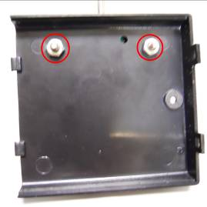
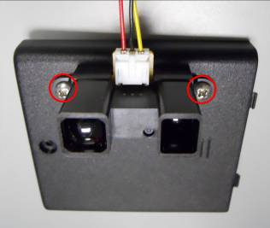

2b 2c

- Serial and Parallel Holder Configuration
  - Correctly insert AA batteries into slots 2-4 (labeled as S2-S4).
  - Pop out the ground (negative) terminal in slot #1.
  - Make sure the shield wire is at least 2 inches long and stripped at each end.
    - Using two-inches of 18 AWG shield wire, connect it around the ground terminal.
  - Slide the ground terminal into slot #1 and slide the other end of the shield wire under the positive terminal. Use a multimeter to verify that you made a proper configuration.
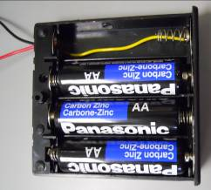
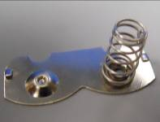
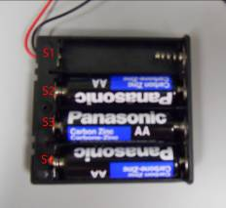

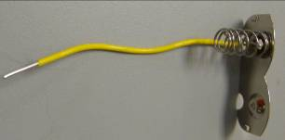

3a 3b 3c 3d
- Sensor Connections
  - Run the ground (black) and VCC (red) wires coming out of the sensor unit through the hole on the battery holder lid (made in 1e).
  - Run the exiting ground (black) and VCC (red) wires from the lower part of the battery holder back inside to slot #1 (using hole made in 1f).
  - Group the ground (black) wire from the sensor and the holder along with an additional ground (black) wire inside the battery holder. Connect all three wires with a wire-connector. Run the third wire added out through the hole in the lower part of the battery holder (made in 1e).
  - Group VCC wires from the sensor unit and the battery holder. Connect them using a wire-connector.
  - Neatly place all connected components inside slot #1 of battery holder and close the battery holder.
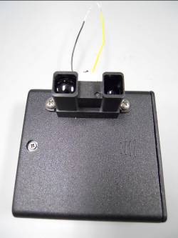
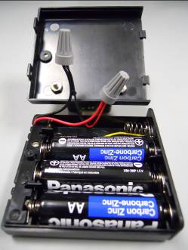
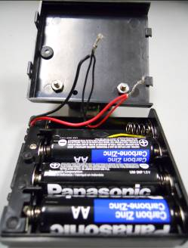
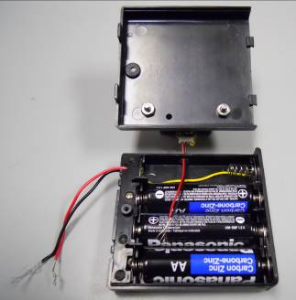

4a 4c 4d 4e

- Alligator Clips
  - Connect alligator clips to corresponding sensor output wire (yellow) and battery holder ground (black). Use a red alligator clip for the yellow wire and a black alligator clip for the black wire.
  - Use a bit of electrical tape to secure good connections.

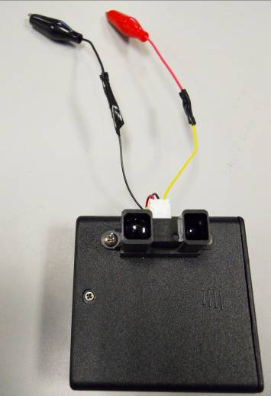
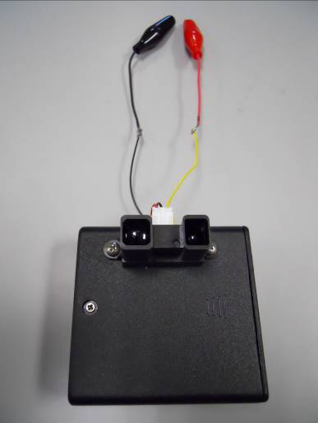

5a 5b

