ARK Mirror and Microsoft Kinect

In its original iteration, the ARK Mirror software was ported to work exclusively with Microsoft Kinect technology. Microsoft has since discontinued the Kinect. However, if you have a Kinect, you may still use the ARK Mirror software. If you have any questions, please contact the developers: https://www.nitrc.org/projects/ar_mirror

The ARK Mirror can use the Microsoft Kinect, an integrated sensor array that was originally designed as a video gaming device. The Kinect has a “normal” camera called a color camera, two different infrared cameras meant for detecting depth, and four microphones that it can use to locate sound sources. The real power of the Kinect, however, is in the software that Microsoft has developed around it. The core feature of the Kinect is that it renders the idea of the video game controller totally useless – using the Kinect, your entire body becomes the controller. Microsoft’s Kinect software receives all the sensor data from the cameras and uses them to create a 3-dimensional virtual space containing all that the Kinect sees. This space, called “CameraSpace,” has a strict measurement and reference system that allows the position of any object to be known to within a few millimeters. The Kinect’s image processing algorithms can identify human bodies within CameraSpace, and can keep track of any of 20+ pre-programmed joints on each body (e.g., head, left shoulder, left ankle, right thumb).

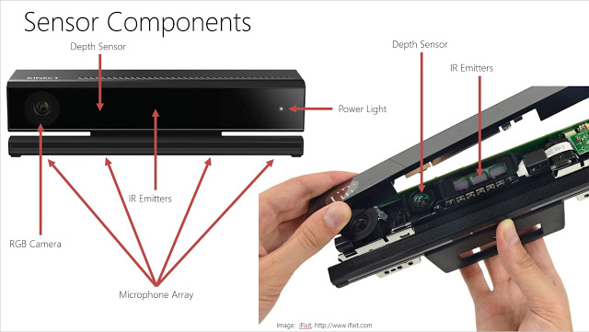

Source/Rights: Microsoft Corporation, 2013
Diagram of Kinect sensors

