Constructing Sonoran Desert:
Sample Food Chain and Mathematical Modeling of Energy Flow

The Sun
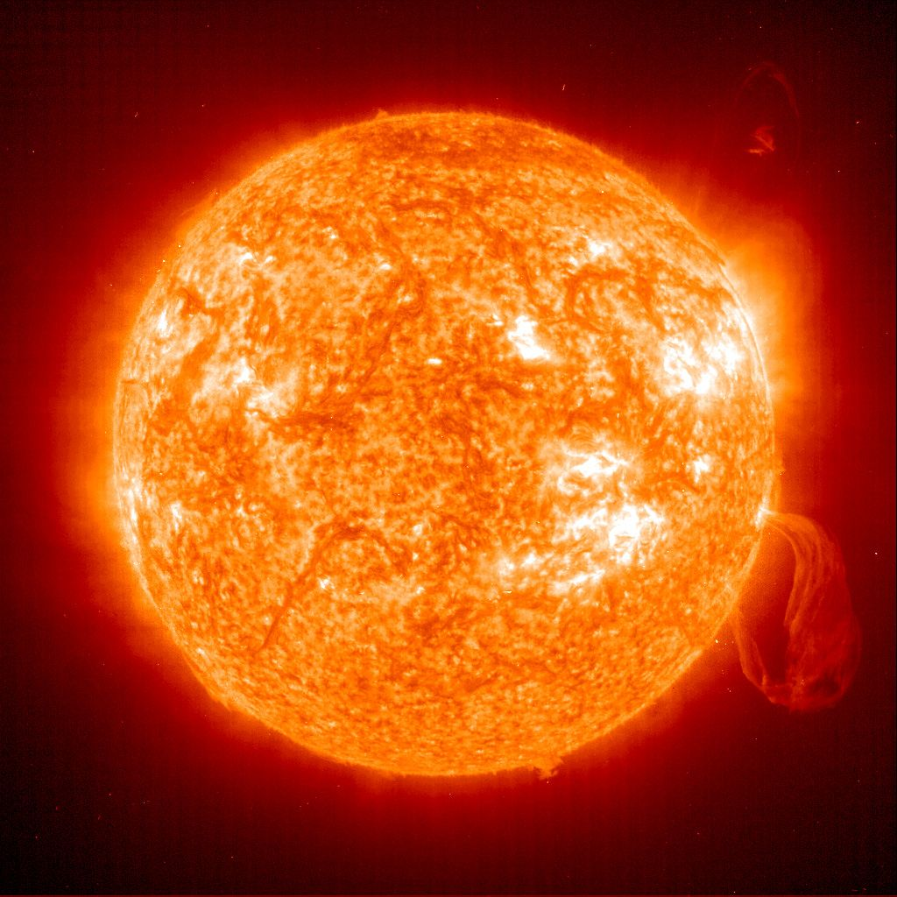
⬇
Prickly Pear Cacti captures and stores 100 calories
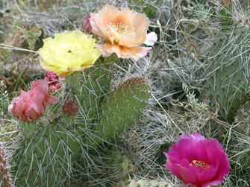
⬇
Desert Iguana eats the prickly pears, and produces heat and uses energy to move. Only 10 calories from the prickly pear are turned into flesh.
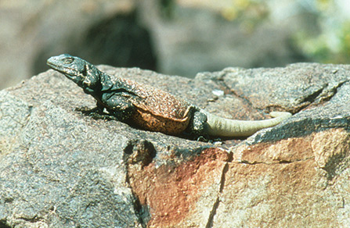
⬇
Ferruginous Hawk eats the Iguana and need lots of energy for flight! Only 10 calories from the Iguana and 1 calorie of the original energy from the prickly pear is put into growth of the hawk.

ONLY 10% OF THE ENERGY IS CARRIED TO THE NEXT TROPHIC LEVEL
Energy available = Original Calories * (0.10)^{(n-1)}
n = number of trophic levels climbed

