Floppy Heart Valves Challenge Question Handout
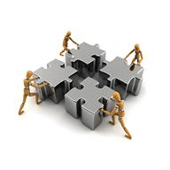
Challenge Question

You are the lead engineer for a biomaterials company that has a cardiovascular systems client who wants you to develop a model that can be used to test the properties of heart valves without using real specimens. How might you go about accomplishing this task? What information do you need to create an accurate model? How could your materials be tested?
Brainstorming

Write down all the ideas that your group develops as to how to solve this challenge.

What do you already know about this problem?

What do you need to know to better understand this problem?

Where might you look to find answers to the questions you develop?

Interview with a Biomedical Engineer (transcript)
Read this interview to learn more about the properties of heart valves.
I’d like to introduce M. K. Sewell-Loftin, a doctoral candidate in biomedical engineering at Vanderbilt University in Tennessee.
Interviewer: When testing heart valves, what properties of the valve are important to consider?
MKS-L: Heart valve leaflets are thin, flexible tissues that undergo billions of open/close cycles during their lifetimes. Because they are thin and flexible, the leaflets are able to be pushed open during systole by only the force of the flowing blood. During diastole, the leaflets must be able to coapt to prevent retrograde blood flow. Even though they are flexible, the stiffness of the valve leaflets is important during diastole; the valve needs to be able to support the “weight” of the blood above it. Otherwise blood will flow backward into the heart, which is a symptom in many types of valve diseases. So you want valves to have leaflets stiff enough to support blood but soft enough to remain flexible.
Another important property is mechanical anisotropy, or the directionality of the mechanical properties. Collagen fibers (located in the fibrosa, on the aortic side of the valve) are aligned circumferentially in the valve leaflets, making the valve mechanically stronger in this direction compared to the radial direction. These are what give the valve its strength to prevent retrograde blood flow during diastole. So if we take a valve leaflet and stretch it in the circumferential direction, we see that it is “stiffer” than if the same leaflet is stretched in the radial direction.
The trilaminar structure of the valve is also an important aspect of valve biomechanics. The structure and function of the valve are linked such that function influences structure and structure determines function. The fibrosa (collagen-rich layer) is responsible for the mechanical strength of the valve. The spongiosa (glycosaminoglycan-rich layer) acts as a lubricant and shock-absorber. Finally, the elastin-rich ventricularis is responsible for the stretching that occurs during each cycle. The elastin is relaxed when the valve is open (systole) but stretches so that the leaflets can fully coapt during diastole. The percent composition and orientation of these proteins are important properties that determine how the valve is functioning.
Interviewer: What methods do you use to test these properties in the lab?
MKS-L: To test macro-mechanical properties, our lab has a biaxial strain device. With this, we can take a sample valve leaflet and apply known loads (stresses) to the sample in the radial and circumferential directions simultaneously. We measure the strain (stretch) of the valve in response, and we get data about how compliant or stiff the valve is in each direction.
To look at micromechanical properties, our lab uses an atomic force microscope (AFM). This is a specially designed microscope that enables us to control a nanoscale tip and its interactions with a sample. Based on how the tip moves over the sample, how much force we apply, and the shape/size of the tip, we can collect stiffness (modulus) data from the tissue. This is a good technique in that we can also perform histology (such as Movat’s pentachrome stain) on the sample, so that we can correlate mechanical properties with protein content. For instance, Movat’s shows clearly the three layers in the aortic valve, so that we can compare stiffness between these layers to better understand the valve mechanical properties.

General Information about the Heart and Heart Valves
The heart is a pump that, as cardiac tissues contract, pushes blood from one chamber to the next or from one chamber into a blood vessel. To help ensure that blood only flows in one direction, a series of valves are strategically placed within the heart and in blood vessels immediately outside of the heart. These valves open to permit blood flow, and then close to prevent blood backflow (cardiac regurgitation).
Generally speaking, blood flow through the heart and body follows this path: Deoxygenated blood from the body enters the heart from the superior and inferior vena cava via the right atrium, and then passes through the tricuspid valve into the right ventricle. Then blood is pumped through the pulmonary valve into the pulmonary arteries, which lead to the lungs, where the blood picks up oxygen. The newly oxygenated blood leaves the lungs and returns to the heart via the pulmonary veins. This blood enters into the left atrium, and passes through the bicuspid (mitral) valve into the left ventricle. The pumping action of the heart pushes the blood out of the left ventricle through the aortic valve into the aorta, which is ultimately responsible for leading oxygen rich blood into the body.
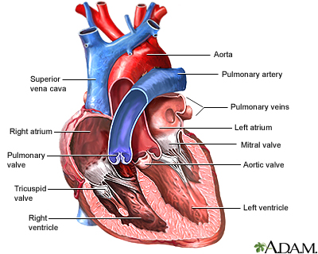

The two valves within the heart—the tricuspid and mitral valves—prevent blood backflow from the ventricles into the atria. Because of the force of the blood as it is pumped within the heart, the leaflets of each of these valves are anchored into place by strands of mostly collagen and elastin called chordae tendineae. These anchors prevent the valve leaflets from opening in the wrong direction (into the atria).
The two valves that are directly outside of the heart—the pulmonary and aortic valves—are both tricuspid valves (possessing three leaflets each) and are not anchored in place by tissue. Instead, each of the valve leaflets relies on its tissue structure to withstand the pressures exerted by blood flow.

General Information about Aortic Valves
Aortic valves are located between the left ventricle of the heart and the aorta. They are semi-lunar valves composed of three leaflets. During diastole (when the ventricles relax), the valve closes to prevent regurgitation (backflow) of the blood back into the heart. In this way, aortic valves play a major role in helping determine the direction of blood flow. During systole (when the heart contracts, moving blood into the blood vessels), the aortic valve opens, systole permitting blood to move into the aorta. This sequence of events repeats with each cardiac cycle, on average 60 times per minute.
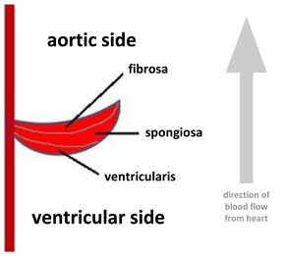
Aortic valves are passive in nature, opening and closing largely because of the flow of blood. When blood is pulsed out of the heart during systole, it forces the valve to open. When the heart relaxes, the change in blood pressure causes the valve to close, allowing all three leaflets to fit snugly together. It is the structure of the aortic valve that enables it to close snugly to prevent cardiac regurgitation.
Figure 1
Human aortic valve leaflets are composed of three distinct tissue layers (trilaminar; see Figure 1). The ventricularis layer faces the left ventricle. The spongiosa layer is the middle valve layer. The aortic side of the leaflet is called the fibrosa layer. Endothelial cells cover these three layers, forming a cell monolayer that protects the valve.
The fibrosa layer is composed of mostly collagen, which aligns in a certain way during the backflow of diastole, allowing the valve to elongate as it closes, forming a complete seal between the left ventricle and the aorta. This aligning of collagen fibers in the fibrosa layer also gives the now closed valves strength to withstand the backward flow of the blood from the aorta, preventing regurgitation.
The ventricularis layer of the aortic leaflet is composed largely of elastin, a protein with the ability to stretch out with stress, but return to its original shape once the stress is removed. When the heart relaxes, blood pressure in the valve forces the leaflets to close. As the collagen in the fibrosa layer aligns to let the valve leaflet stretch and completely seal the blood vessel, the elastin in the ventricularis layer stretches. When the backflow ceases (because the ventricle contracts during systole), the pressure from the backflow eases, permitting the elastin to recoil and thus causing the leaflets to fold up and open the seal so that blood may flow into the aorta.
The spongiosa layer, located between the ventricularis and the fibrosa, is composed of GAGs (glycosaminoglycans), which help to align the collagen and lubricate the movements of the ventricularis and the fibrose during valve leaflet movement.
References
Campbell, N., Reece, J., Urry, L., Cain, M., and Wasserman, S. Biology. Eighth edition. San Francisco, CA: Benjamin-Cummings Publishing Co., 2007.
Nagatomi, Jiro. Mechanobiology Handbook. Boca Raton, FL: CRC Press, 2011.

