Forces, Elasticity, Stress, Strain and Young’s Modulus
Forces Exerted on Aortic Valves during Blood Flow
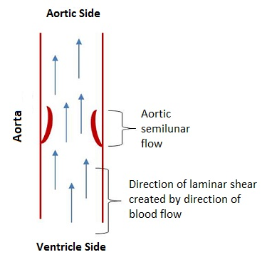
When the heart is pumping during systole, blood is forced through the heart and the various vessels associated with blood flow. As the blood exits the left ventricle, it passes through the aortic semilunar valve. The flow of blood, coupled with the mechanical structure of the heart valve, causes the valve to open. Essentially, the flow of blood and the forces associated with it cause the elastin in the ventricularis layer to “relax,” permitting the valve to recoil to the open position. When the valve is open, it experiences laminar flow across the ventricularis layer of the heart valve (see diagram to the right).

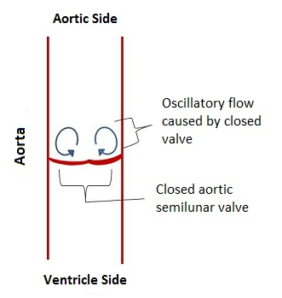
During diastole, the ventricles relax, allowing the flow of blood to change. During this time, the backflow of blood into the heart applies a force on the aortic semilunar valve and causes it to close. The force that is now exerted on the aortic side of the heart valve (the fibrosa layer of the valve) causes the collagen in that layer to move slightly to reinforce the valve. This rearrangement of the collagen causes the elastin in the ventricularis layer to stretch out some, allowing the three leaflets of the valve to meet in the middle and completely seal the valve and prevent blood regurgitation. This change in blood flow means that the valve is no longer experiencing laminar flow. However, the movement of the blood creates some different currents on the aortic side of the valve (see diagram to the right ); this flow is oscillatory in nature.

Elasticity and Young’s Modulus
Elasticity describes a material property in which the material returns to its original shape after stress has been applied and then removed. When thinking about elasticity, think about a coiled metal spring or a rubber band. Imagine applying stress to a rubber band by pulling on it. Once the stress is removed (you stop pulling on it), the rubber band recoils to its original shape. The exception to this is applying too much stress to the rubber band and causing permanent deformation (the rubber band breaks or does not return to its original shape).
So, what is stress? In this situation, stress is an amount of force applied to an object. The stress applied to the rubber band temporarily changes its shape, until the stress is removed.
All materials experience some change with the application of force. However, different materials respond differently to stress. For example, a steel beam reacts differently to stress than a bungee cord. A measurement of the elasticity of a material is called the Young’s modulus, and is determined as a ratio of stress to strain:
Young’s Modulus (Y) =stress/strain
Young’s modulus can be used in the following equation:
F = $Y(\frac{∆L}{L_{0}})A$
In this equation, F is equal to the force applied to the structure, Y is the Young’s modulus for the material, ΔL is the change in length of the material when the force is applied to it, L₀ is the initial length, and A is the cross-sectional area of the material.
Example Young’s modulus for some different materials:
Pig heart valve 1.2 10⁶ Pascal (Pa)
Rubber 1.0 10⁸ Pa
Tooth enamel 8.3 10⁹ Pa
Steel 2 10¹¹ Pa
Carbon nanotube 1 10¹² Pa
Young’s Modulus Practice Problem
Problem: A steel cable with an initial length of 20 meters and a diameter of .05 m suspends an elevator car in its shaft. Three people, having a total mass of 238 kg, enter the elevator car. Given the elevator cable is made of steel, what is the amount of stretch that the cable experiences when the three passengers enter the elevator car?
Solution: We already know:
L₀ = 20 m (given)
Y = 200000000000 Pa (given)
A $=πr^{2}$= 3.14 (.025m)² = .002 m² (using given diameter of .05 m)
F = ma = 238 kg 9.8m/s² = 2332N (using given mass of people and the Earth’s gravitational acceleration)
ΔL = unknown

Using what we know, we can do the following calculations:
F = $Y(\frac{∆L}{L_{0}})A$
2332 N = (200000000000 Pa) (x/20 m) (.002 m²)
2332=(x/20) (400000000)
0.0000058 = (x/20)
0.00012 = x
Thus, the cable will stretch .00012 m when the three passengers enter the elevator car.
Stress and Strain
Stress (force divided by cross-sectional area) can be expressed as:
σ= F/A
Strain (change in length divided by initial length) can be expressed as:
ɛ=$∆L/L_{0}$
Remember the equation covered earlier:
F= $Y(\frac{∆L}{L_{0}})A$
This equation can be rewritten by dividing both sides by A to look like:
$$\frac{F}{A}=Y(\frac{∆L}{L_{0}})$$
This shows that stress (F/A) is proportional to strain (ΔL/L₀), in the elastic region of the stress/strain curve, and can thus be graphed. When these are graphed, with the stress on the y-axis and the strain on the x-axis, the slope of the resulting best-fit line is equal to the Young’s modulus of the material.
