Wristwatch Design for the Visually Impaired
Activity – Engineering Design Process Packet
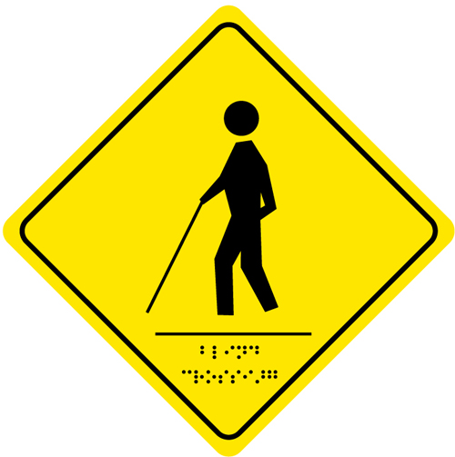
Client Statement
Time Incorporated, a leading watch manufacturing company in New England whose target audience is the young adult consumer (11-19-years old), has hired you, the engineers of Rising Star Academy. A recent development in the school of the owner’s children has given her the idea to develop a new wristwatch: a watch designed to help people with severe visual impairment. Your challenge is to develop a new wristwatch that fits the average 11-19-year old person, looks good, and is easy to understand. The number one goal of this product is to help young adults with visual impairment feel more independent.
Problem Statement (Define the problem in detail)

Functions (The action that the design or product is created for)

Objectives (The attributes of the design or product)

Constraints (restrictions or limitations)

Background Research
Use the internet to research telling time, wristwatches, how clocks work, visual impairment and other related topics. Make sure to keep a record of relevant material and the website(s) you used for research.
Design Solutions
On a piece of graph paper, sketch three (minimum) possible design solutions. Discuss each design with team members. Create a pros and cons T-chart for each design on the backside of your design sketch.
Creation of Prototype (describe your selected design and why you chose the design you did)

Test Design
Develop a 3-4 question survey to evaluate the effectiveness of your wristwatch design. The survey should evaluate the visual appeal of the wristwatch, the ease of understanding and at least one other focus area. Have five people evaluate your group’s wristwatch design
Test Results
Write out survey questions below. Use complete sentences. | Survey 1 | Survey 2 | Survey 3 | Survey 4 | Survey 5 | Average Score

Evaluation of Results (Based on the test results was your design effective? How do you know?)

Future Recommendations (Based on the test results and your evaluation of the results, what you would recommend for improvements to your design, why would you make the selected changes)

Sketch any design changes in the space below (be sure to label parts of watch):

Identify the person (or group) who filled each role during the design process.

