**Air Pollution in the Pacific Northwest Worksheet** Name ______________________

List a few general facts about Nitrogen Dioxide air pollution below:

|  |
| --- |
|  |

**Emissions Inventory** for *nitrogen oxides* in the lower **atmosphere**:

Provided by the **Environmental Protection Agency**

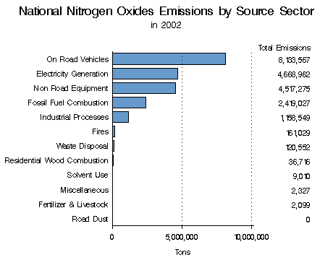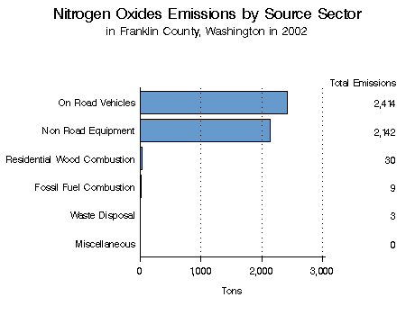

|  |  |
| --- | --- |
| **In the box below, answer the two questions: What are the top two sources of nitrogen oxides in the USA? How much is emitted per year?**  **(Include Units)** | **In the box below, answer the two questions: What are the top two sources of nitrogen oxides in *Franklin County* (Pasco)? How much is emitted per year? (Include Units)** |
|  |  |

**Label the Cities, Axes, and Title in the plot below:**

What are the coordinates of each city?

|  |  |  |
| --- | --- | --- |
| CITY | Latitude | Longitude |
|  |  |  |
|  |  |  |
|  |  |  |
|  |  |  |
|  |  |  |

What is the largest value shown on the maps of nitrogen dioxide?

Which city is it in?

Is it from the model or the satellite?

**November 2007 –***nitrogen dioxide*

AIR QUALITY MODEL: SATELLITE MEASUREMENT:

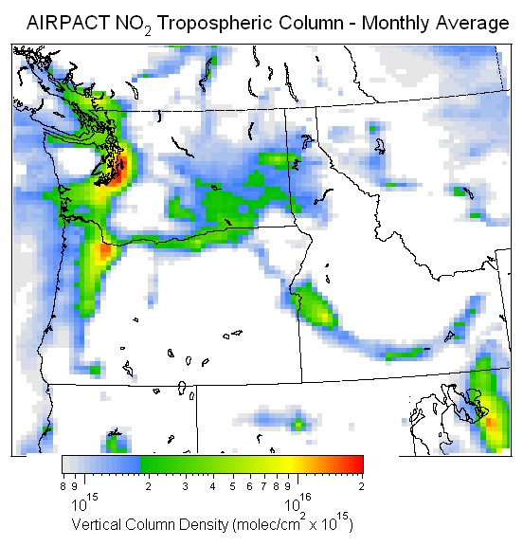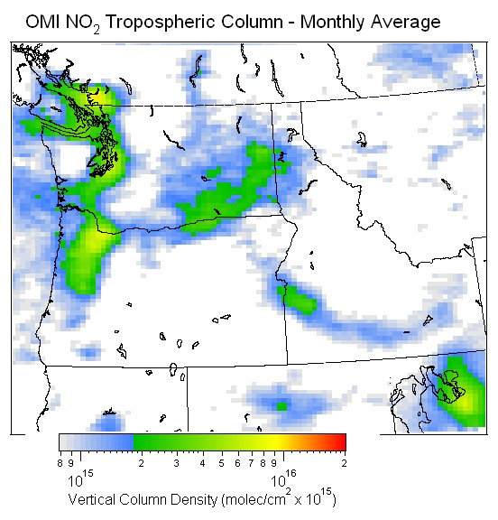

Complete the table below:

|  |  |  |  |  |
| --- | --- | --- | --- | --- |
|  | AIRPACT NO2 | OMI NO2 | AIRPACT/OMI Ratio | AIRPACT - OMI Difference |
| **Seattle** |  |  |  |  |
| **Portland** |  |  |  |  |
| **Vancouver** |  |  |  |  |
| **Pasco** |  |  |  |  |
| **Spokane** |  |  |  |  |

Which cities show the best agreement between the modeled (AIRPACT) and satellite (OMI) concentrations of nitrogen dioxide? (Be specific – use your calculation and graph results from Excel to explain why).

|  |
| --- |
|  |

Which cities show the worst agreement between the modeled (AIRPACT) and satellite (OMI) concentrations of nitrogen dioxide? (Be specific – use your calculations and graph results from Excel to explain why).

|  |
| --- |
|  |