All About Waves—Notes Outline Answers
A wave is a disturbance that carries energy from one place to another.
Matter is NOT carried with the wave! A wave can move through matter (a medium). If it must have a medium, it is called a mechanical wave. If it can travel without a medium (such as in space), it is called an electromagnetic wave.
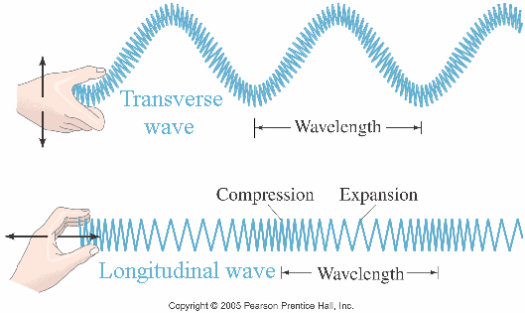
Wave Types
- Transverse waves: Waves in which the medium moves at right angles to the wave direction.
Parts of a transverse wave:
crest: the highest point of the wave
trough: the lowest point of the wave
- Compressional (longitudinal) wave: Waves in which the medium moves back and forth in the same direction as the wave.
Parts of a compressional wave:
compression: where the particles are close together
Comparing transverse and longitudinal waves.
rarefaction: where the particles are spread apart
Wave properties depend on what type of energy makes the wave.
- wavelength: The distance between one point on a wave and the exact same place on the next wave.
- frequency: How many waves go past a point in one second; measured in hertz (Hz). The higher the frequency, the more energy in the wave.
- amplitude: How far the medium (crests and troughs, or compressions and rarefactions) moves from rest position (the place the medium is when not moving). The more energy a wave carries, the larger its amplitude. Amplitude is related to energy by E = CA².
- wave speed: Depends on the medium the wave is traveling in. This varies in solids, liquids and gases.
Equation for calculating wave speed:
wave speed = wavelength (in m) x frequency (in Hz)
Problem: So- if a wave has a wave speed of 1000 m/s and a frequency of 500 Hz, what is its wavelength? Answer: wavelength = 2 m
Changing Wave Direction

reflection: When waves bounce off a surface. If the surface is flat, the angle at which the wave hits the surface will be the same as the angle that the wave leaves the surface. In other words, the angle in equals the angle out. This is called the law of reflection.

refraction: Waves can bend; this happens when a wave enters a medium and its speed changes; the amount of bending depends on the medium it is entering

diffraction: The bending of waves around an object. The amount of bending depends on the size of the obstacle and the size of the waves.
A demonstration of refraction.

large obstacle, small wavelength = low diffraction

small obstacle, large wavelength = large diffraction

