Agricultural Engineering: Cutting through Soil Activity —
The Parts of a Plow Handout

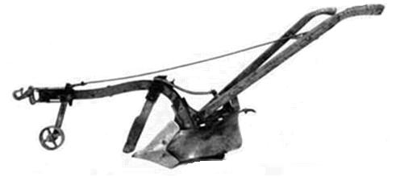
Coulter

Plowshare

Moldboard

Handles

Beam

Hitch

Source: http://www.fhwa.dot.gov/environment/Fspubs/96232802/fig15.jpg

Coulter – A sharp wedge that goes in front of the share and cuts vertically through the soil.
Plowshare – the wedge shaped piece that cuts the soil horizontally.
Moldboard – A curved piece above the plowshare that turns the soil over as it is cut by the plowshare.
Handles – used by the operator to control the plow.
Beam – the main support of the plow.
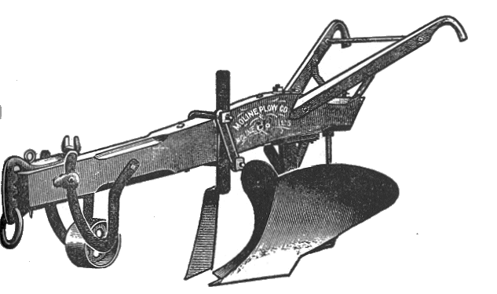
Hitch – used to attach the plow to the horse or oxen.

Another Example Plow

Can you label the parts in the picture below?
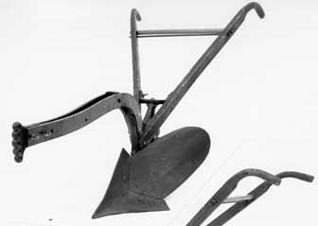

Source: http://www.fhwa.dot.gov/environment/Fspubs/96232802/fig14.jpg

What part is this plow missing?

