Pyramid Building Worksheet

1. If you were going to chop wood, think about the type of axe you would choose. Which of the following two axes would make it easier? (Please circle one axe)
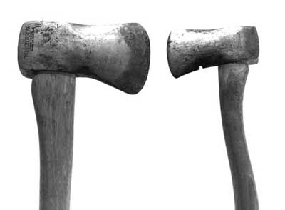
TeachEngineering.org – Free STEM Curriculum for K-12

2. Why would the axe you chose make it easier?
_________________________________________________________________
_________________________________________________________________

3. Would it be easier or harder to cut wood if the axe were sharper? Why?
_________________________________________________________________
_________________________________________________________________
4. What is a force?
_________________________________________________________________
_________________________________________________________________

5. An axe provides an unbalanced force onto wood. This unbalanced force causes parts of the wood to move, and eventually be cut. Balanced forces cause no movement. Can you name another type of unbalanced force? (Example: your legs pushing on bike pedals)
_________________________________________________________________
_________________________________________________________________

