Response & Reaction Worksheet
Pupillary Response Exercise
- Perform this exercise with a partner.
- Dim the room lights. After a few minutes, look at the eyes of your partner and note the pupil sizes (the black center spots in the middle of the eyes).
- Turn on the room lights. Check the pupil sizes again. The pupils should now be smaller.
- This is called the pupillary reflex response. This reflex “automatically” keeps out excessive light that may damage the eyes, and thus protects your eyes for you!
Test Your Reaction Time Exercise
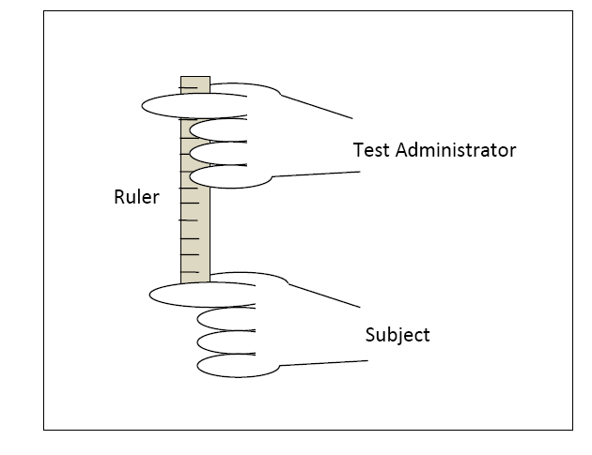
Perform four variations of a reaction test. Record the measured ruler values and any other observations, in the provided data table. Then switch roles and repeat the tests and data collection.
How to Hold the Ruler

- For Test A: Hold a meter-long ruler near the end with the highest number and let it hang down. Have your partner put his/her dominant hand at the bottom of the ruler, not touching it, and be ready to grab the ruler when it drops. Tell your partner that you will drop the ruler sometime in the next five seconds with no countdown warning and that s/he is to try to catch the ruler as fast as s/he can after you drop it. Be consistent in where hands are placed at the start of each trial.
- Record in the data table the point on the ruler (cm or inches) at which your partner catches it.
- Repeat this test with the same subject for a total of three times. Vary the time of dropping within the five-second "drop-zone" so the subject cannot guess when you will drop the ruler.
- For Test B: Conduct the same test with the addition of a countdown warning. Tell your partner that you will drop the ruler at the count of three and say: 1… 2… 3 and drop it when you say 3.
- Record in the data table the point on the ruler where the partner caught it for this trial.
- Repeat this test with a countdown with the same subject for a total of three times.
- For Test C: Conduct the test with no countdown warning and your partner’s eyes closed. Tell your partner that you will drop the ruler any time within a five-second “drop-zone.” Record the data.
- For Test D: Conduct the test with a countdown warning, eyes closed, with the subject using his/her non-dominant hand. Tell your partner that you will drop the ruler at the count of three and say: 1… 2… 3 and drop it when you say 3. Record the data.

Reaction Tests Data Table
Test administrator: ___________________________________ Subject: __________________________________
 | Dominant Hand |  |  | Non-Dominant Hand
Trial # | Test A  Eyes Open  No Countdown | Test B  Eyes Open  Countdown | Test C  Eyes closed  No Countdown | Test D  Eyes Open  Countdown
1
2
3
Average
Results & Analysis Questions
- What order did you follow for the experiments?
List the 4 methods from first to last, in the order you performed them.
- Which method resulted in the fastest reaction time?
- Which method resulted in the slowest reaction time?
- Why do you think those were your fastest and slowest reaction times?
- Does it matter in what order the experiments are done?
- Did you get better with practice?

