**Designing for Disaster Worksheet**

**Objectives:** Investigate how engineers design buildings and structures to withstand earthquakes.

**Materials**: Work in pairs sharing one computer with Internet access.

**Engage:**

1. Look around your classroom. Name one thing that might fail or break during an earthquake. Overall, do you think your school is prepared to withstand an earthquake? Explain why or why not.

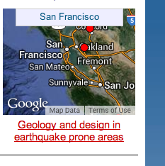

**Explore:**

Navigate to the Earthquakes Living Lab at http://www.teachengineering.org/livinglabs/index.php.

1. Select the San Francisco region (the fourth region). Scroll down the page and select the sixth (last) link: *How do engineers use models and earthquake simulations to test designs for earthquake-resistant buildings and structures?* Watch the earthquakes testing video on YouTube. Pay attention so you’ll be able to answer the next question.

Video website: <https://youtu.be/7hoSqazNmfY>

1. From what you learned in the video, record one type of test that researchers conduct and one design component engineers may use in buildings that experience seismic activity.
2. 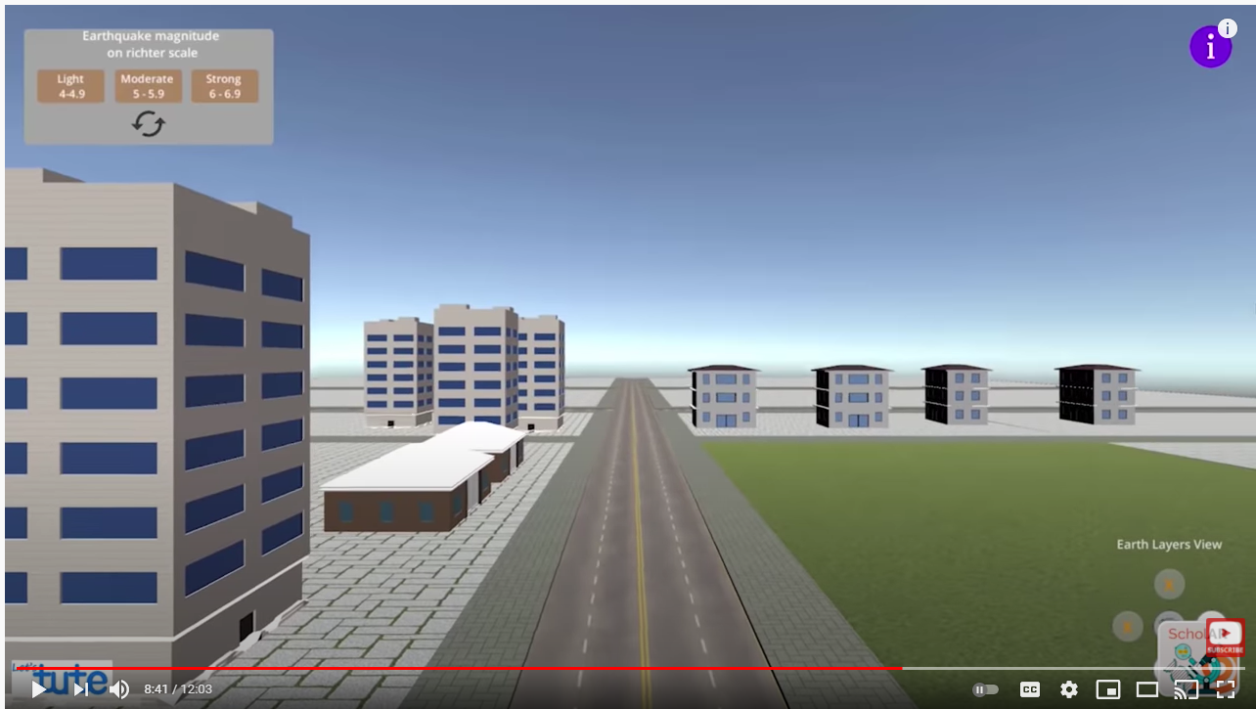Now go to the following video, an in-depth look into why earthquakes occur and an earthquake simulation to see a demonstration of different magnitude earthquakes: <https://youtu.be/RqqqSnaTfQo>
3. From your knowledge gained from the video with the earthquake simulation, note one thing that failed during an earthquake.
4. Navigate back to the San Francisco Earthquakes Living Lab page > select the fourth link titled, *How do earthquakes affect buildings?* To watch simulation of how earthquakes affect buildings, go to the USGS link at <https://www.usgs.gov/media/videos/shaking-frontier-building-anchorage-alaska-during-mw71-earthquake-january-24-2016>. Write down two new details you learned from this video on how earthquakes affect buildings.
5. Now go to the following article on the effects of soil type on earthquake damage: <https://www1.wsrb.com/blog/the-effects-of-soil-type-on-earthquake-damage>
6. From the article, which type of ground soil would result in the least amount of damage to buildings?

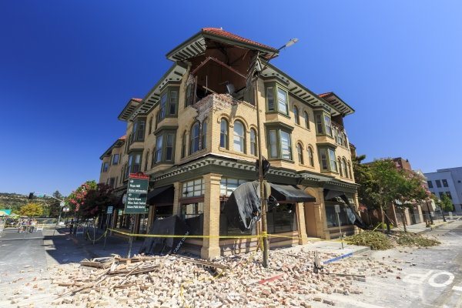

1. Name at least 3 other factors that have an effect on an earthquakes’ damage.
2. Return to the San Francisco Earthquakes Living Lab page > select the sixth link titled, *How do engineers design buildings that withstand the forces of earthquakes?* at <http://www.exploratorium.edu/faultline/damage/building.html>. Read the article, especially the “Location, location, location” section. From the simulation experiments and what you have read, answer the following question:
3. Overall, compare the impact of seismic waves on structures built on solid rock vs. on softer soils.

**Explain:**

1. After having read the entire Faultline “Damage Control: Engineering” article about engineering design principles related to earthquakes at: <http://www.exploratorium.edu/faultline/damage/building.html>, write an answer to the following question: If you were to design a building in an earthquake area, what factors would you consider to result in the **least** amount of damage?

**Elaborate:**

1. Summarize what you learned about how to design building in earthquake-prone areas. Thinking as an engineer, draw a sketch of a building that could withstand a strong earthquake. Explain your key design features.